**DBMS PRACTICALS**

**EX-1**

1. Create a table name STUDENT with following structure.

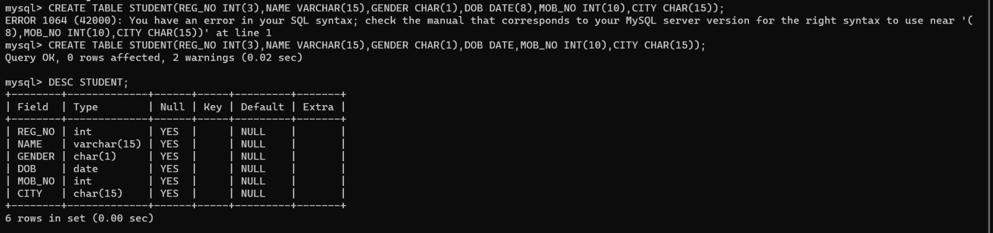

1. Create a table name FACULTY with following structure.

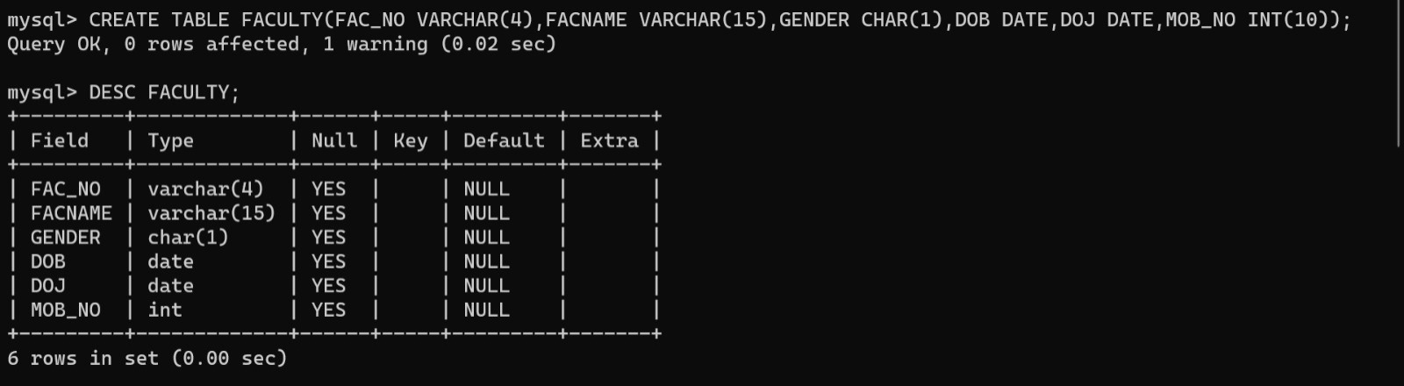

1. Create a table name DEPARTMENT with the following structure.

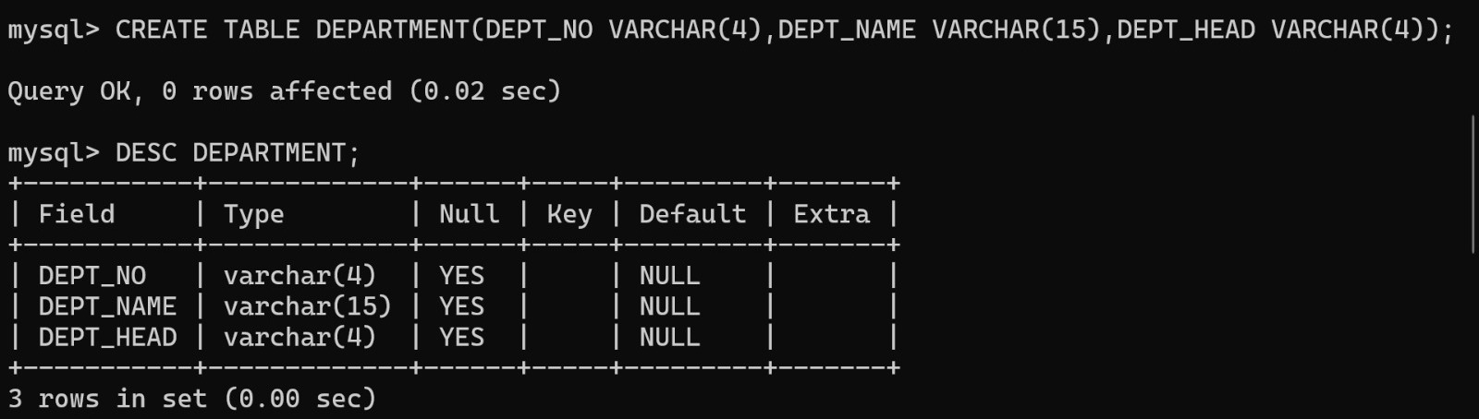

1. Create a table name COURSE with the following structure.

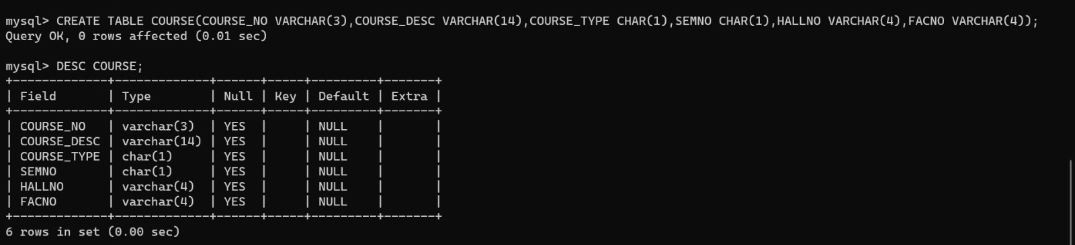

1. Modify the table FACULTY by adding a column name DeptNo of datatype varchar(4)

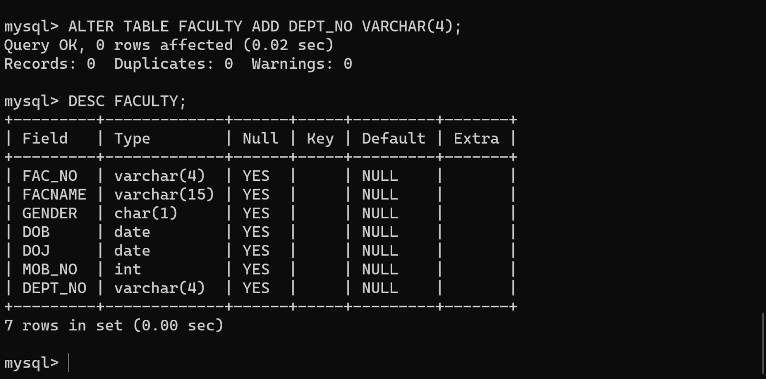

EX-2

1.Alter the table STUDENT with following structure.

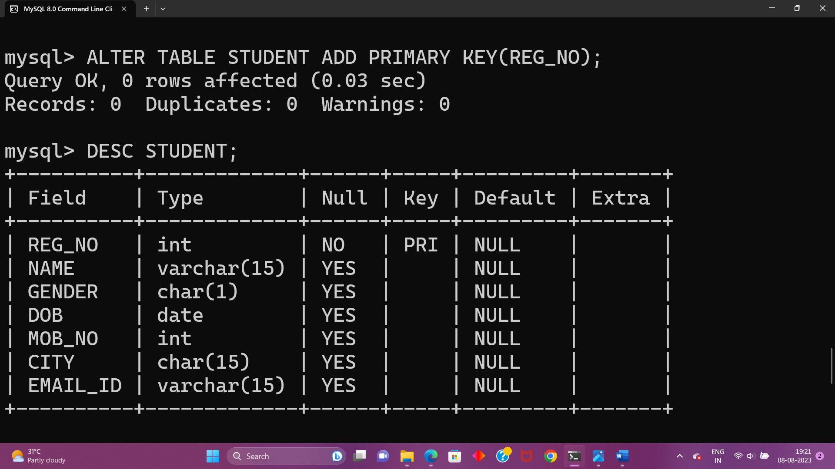

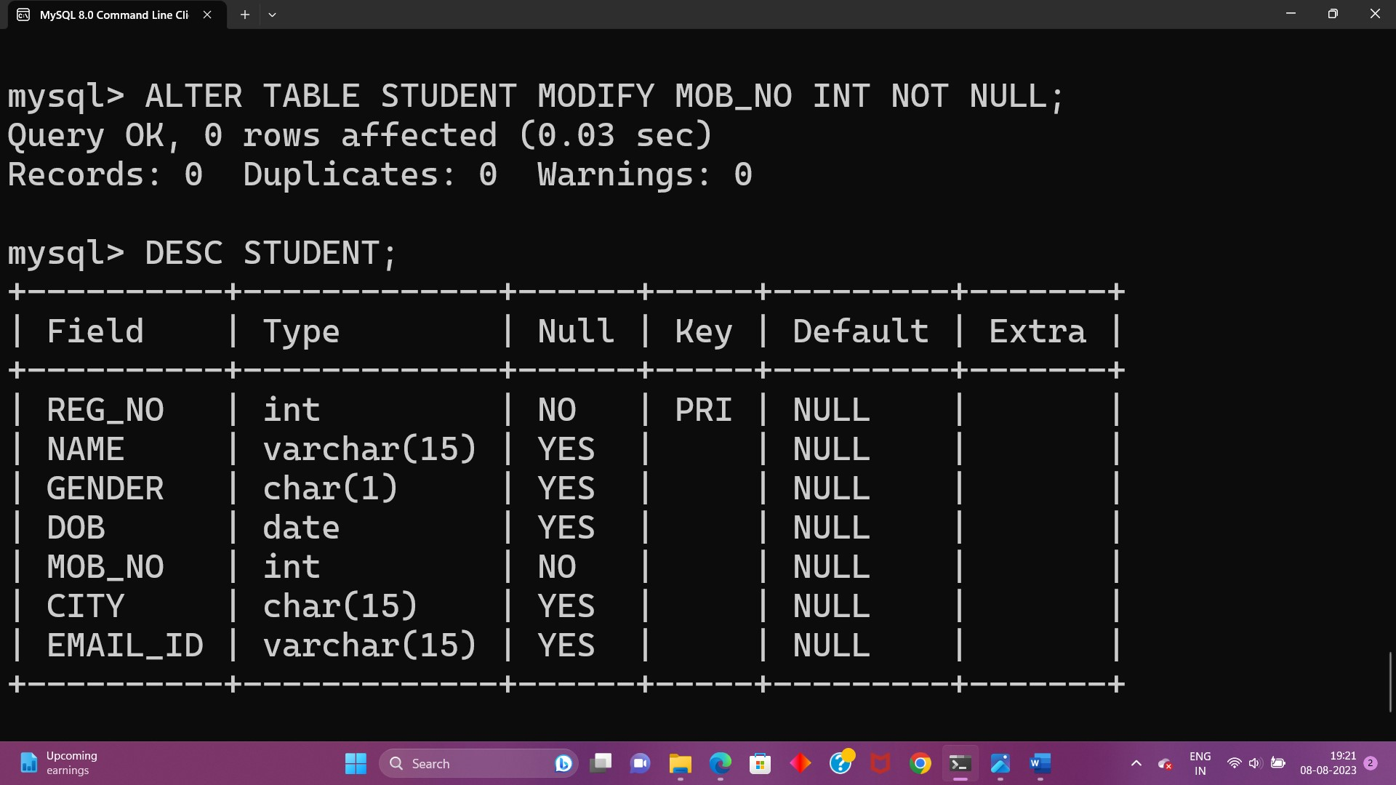

2.Alter the table name FACULTY with following structure.The DeptNo in this table refers to the Department table.

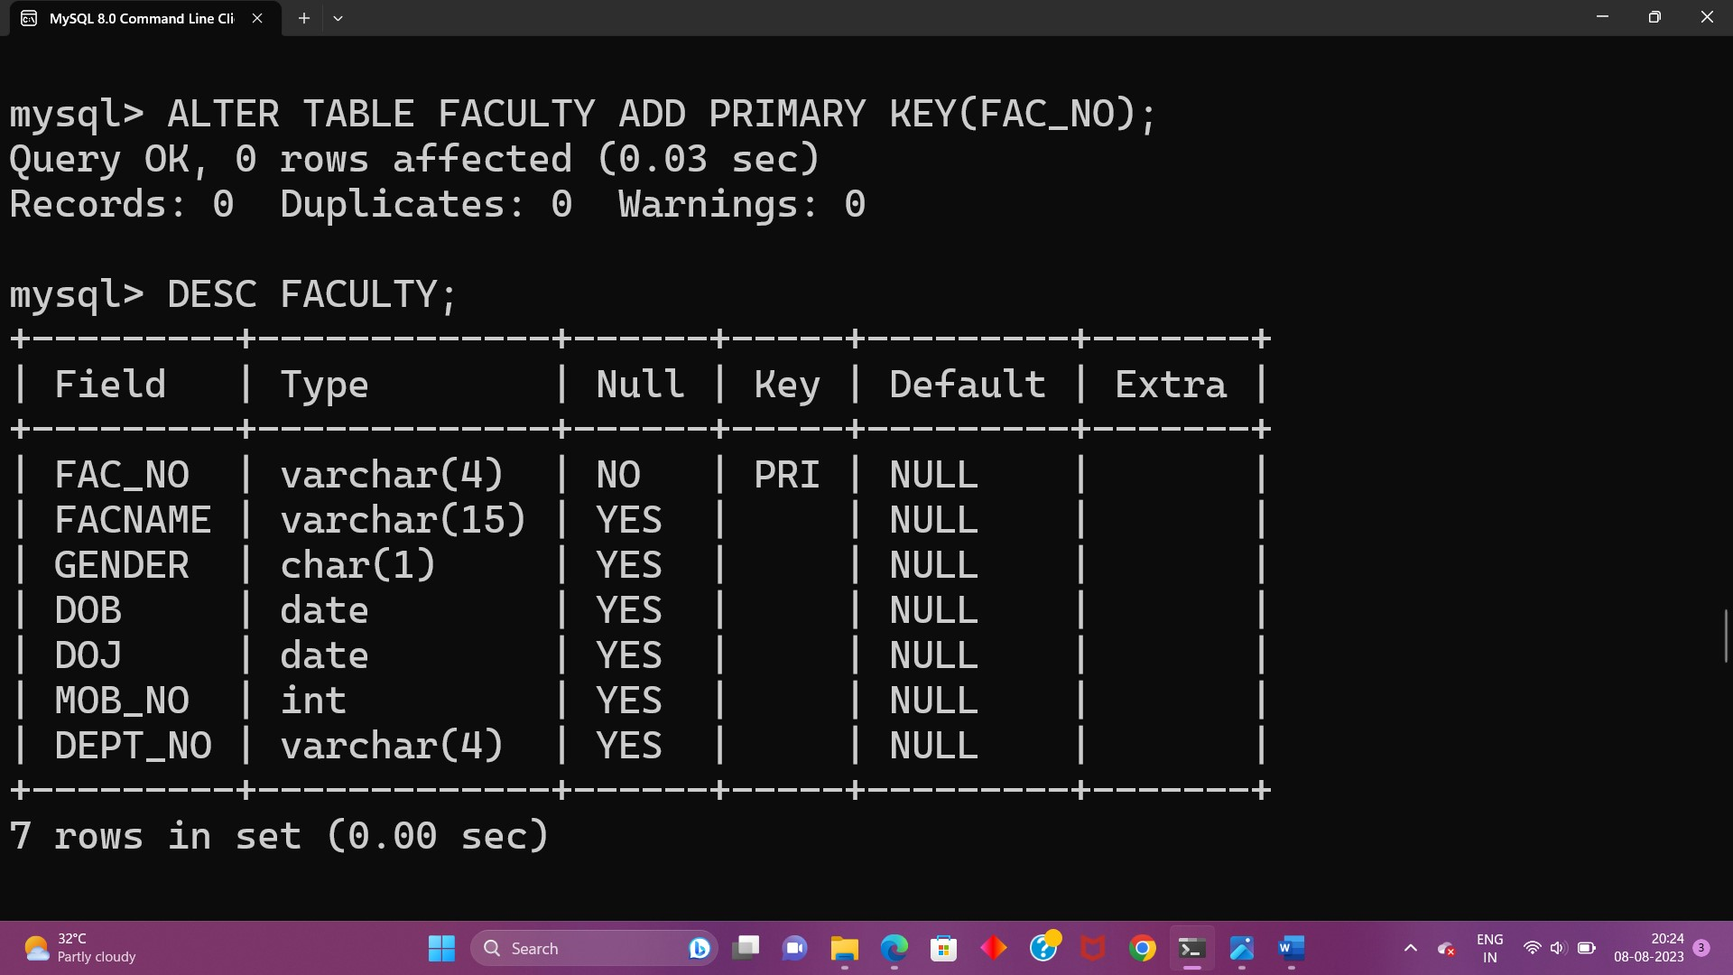

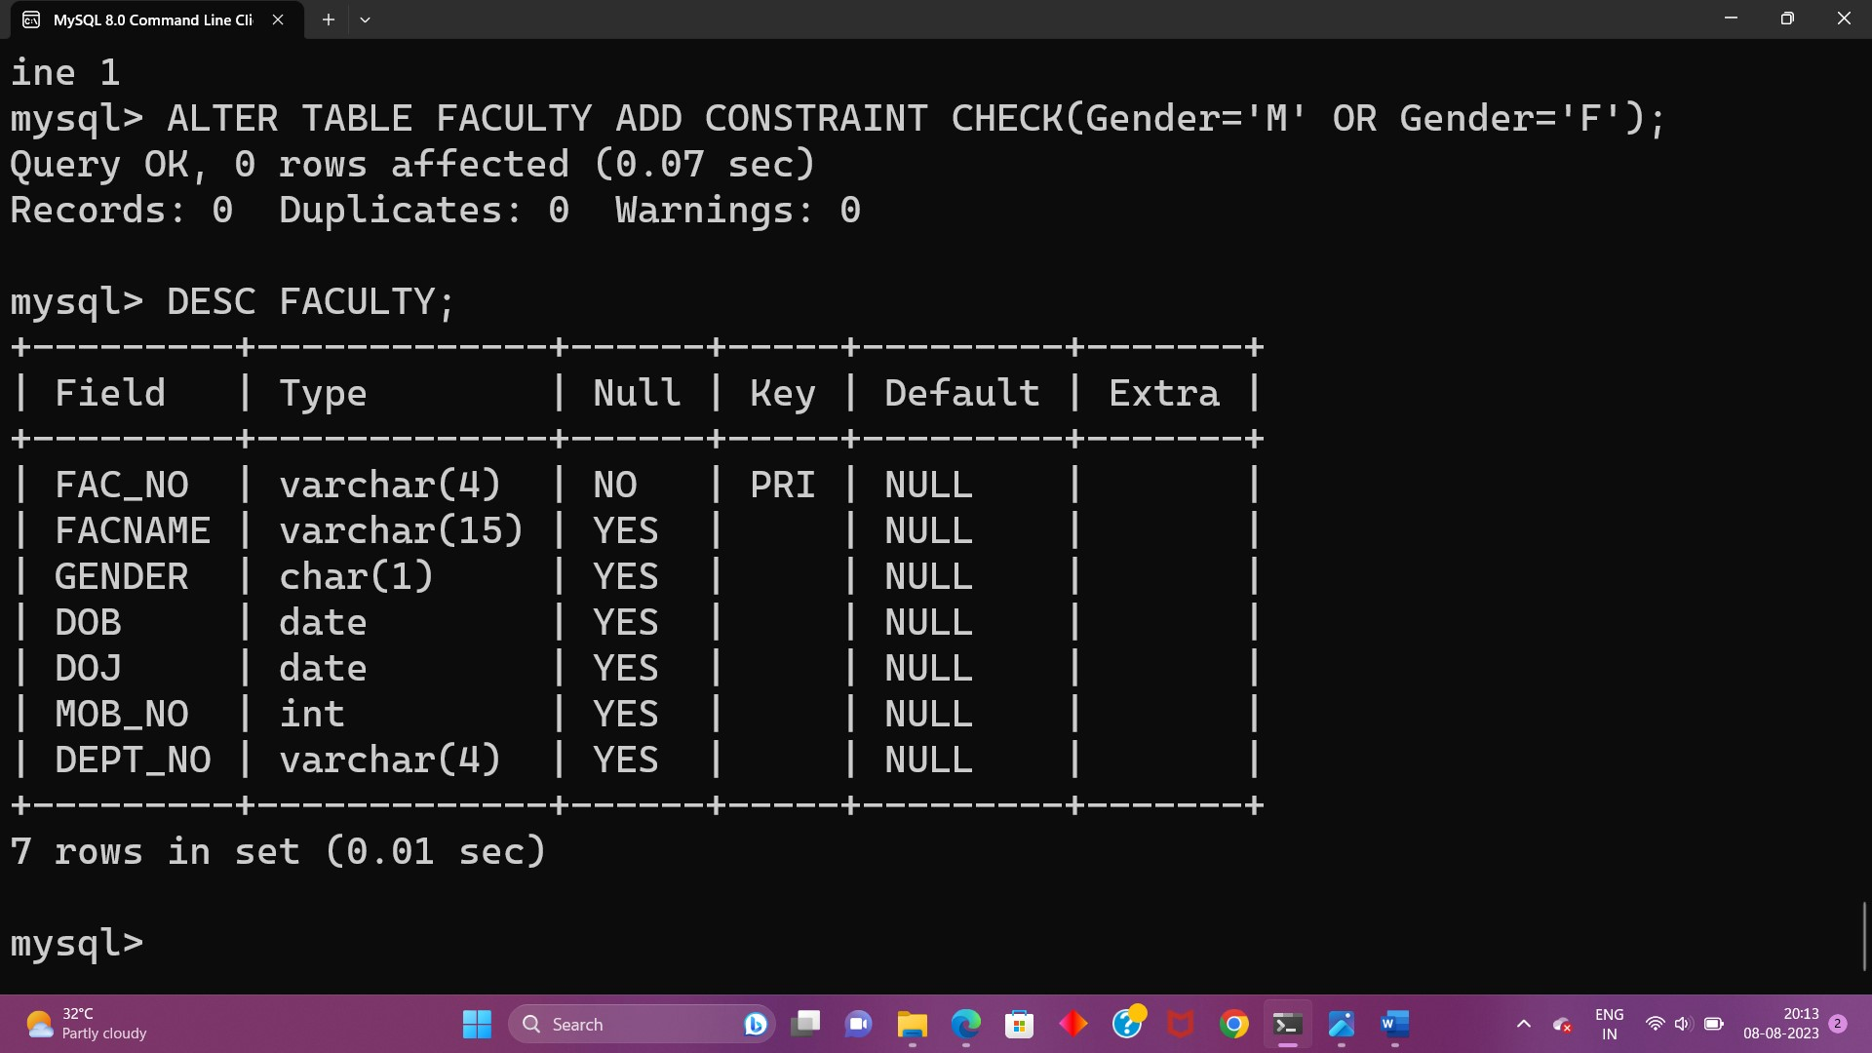

3.Alter the FACULTY table is successfully created,test if you can add a constraint FOREIGN KEY to the DeptNo of this table.

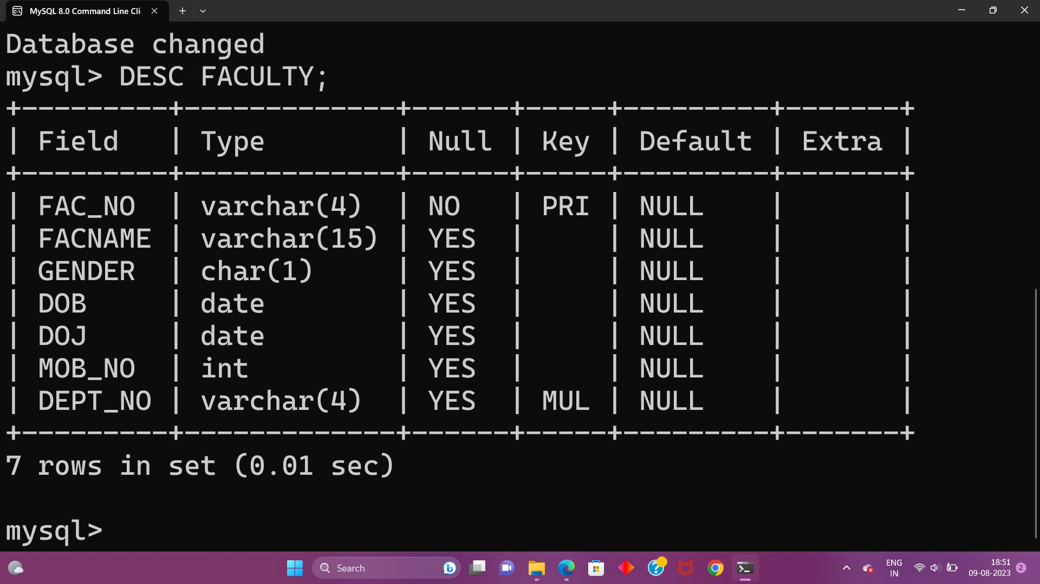

4.Alter the table name DEPARTMENT with following structure.

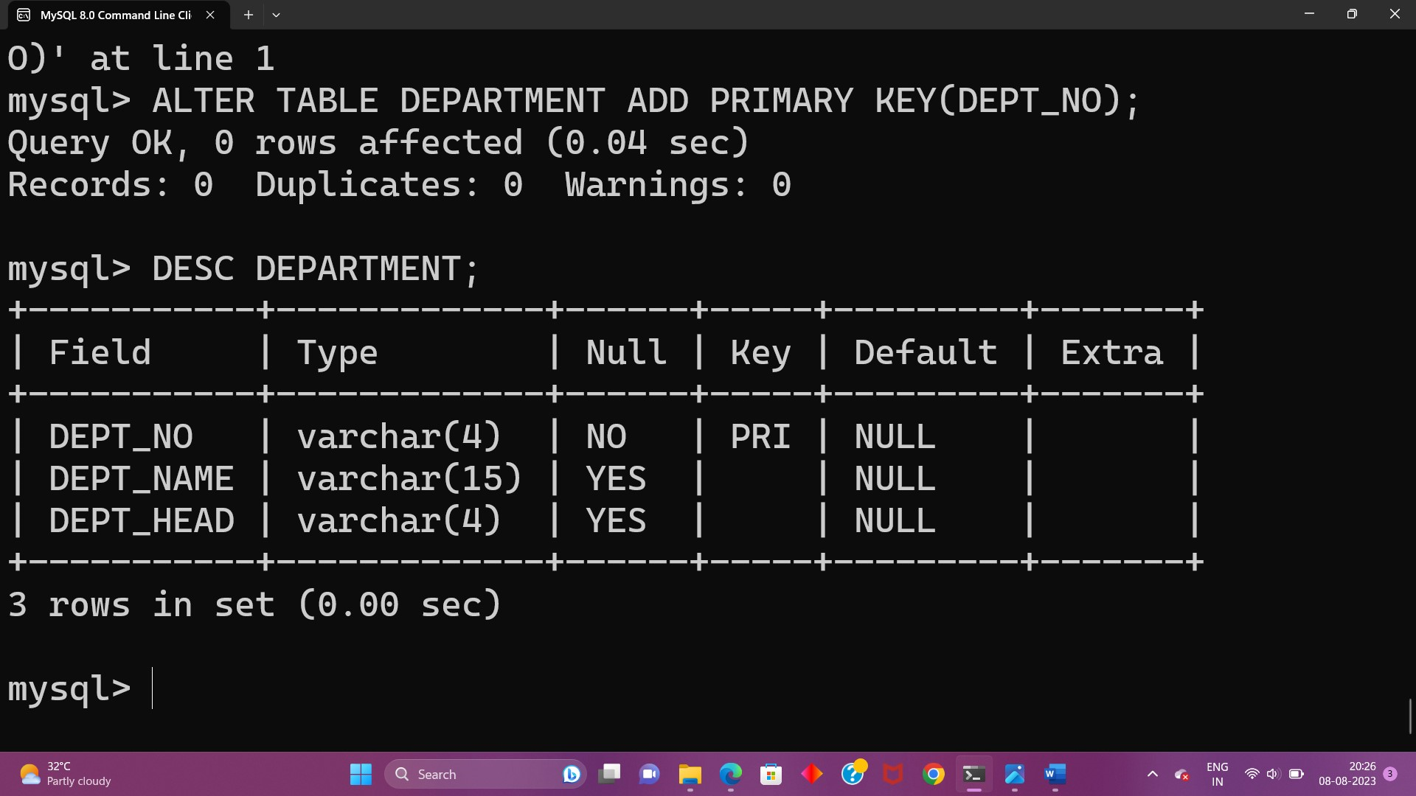

5.Alter the table name COURSE with following structure.

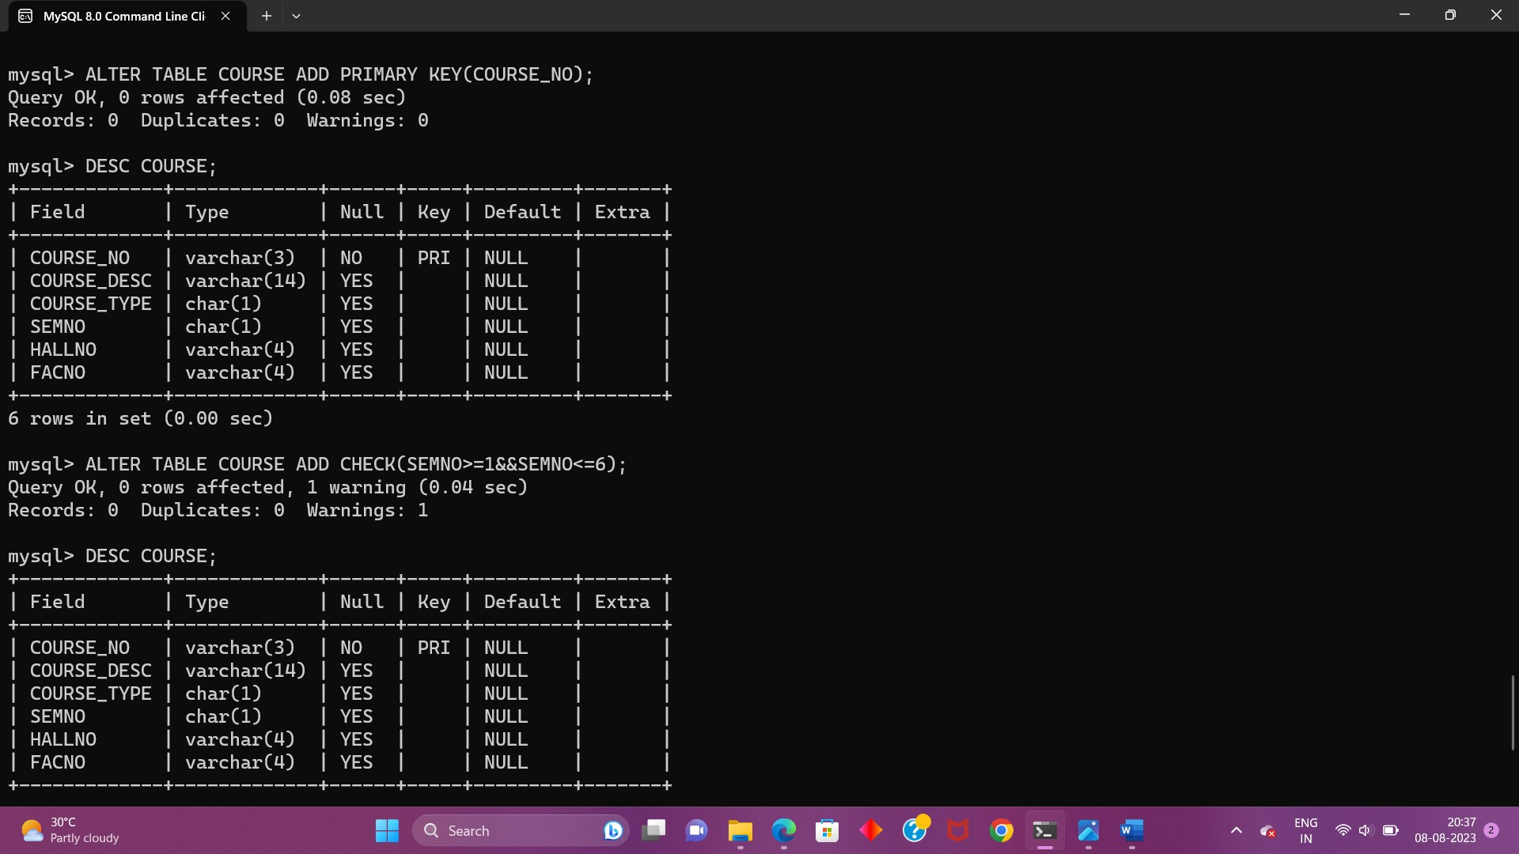

**EX-3**

1.Populate all the five tables with your own data.

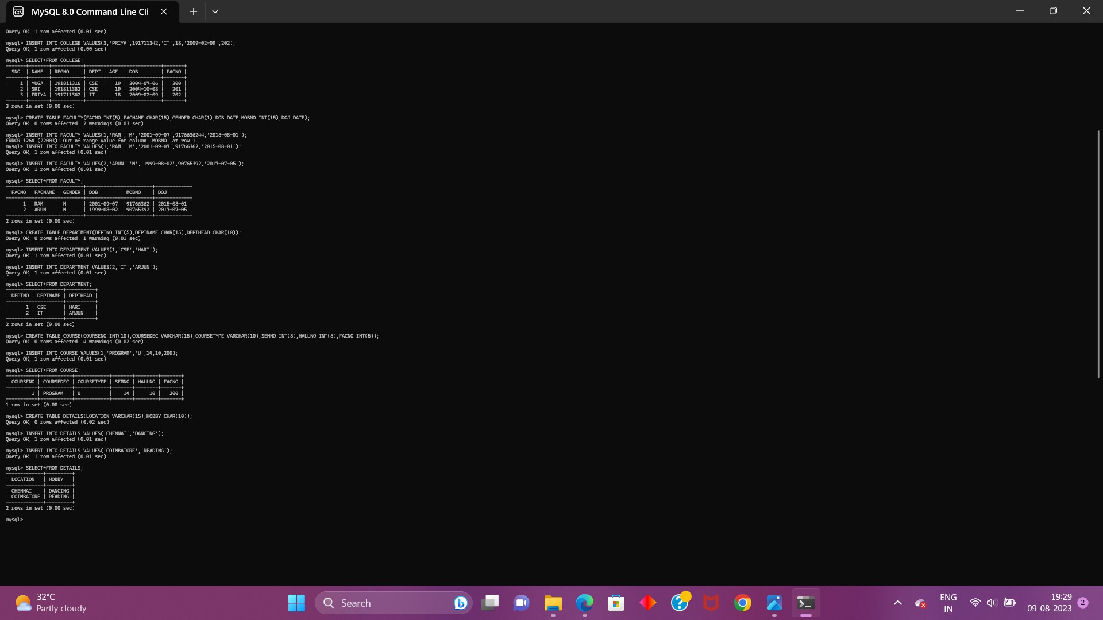

2.Update the value of the student name whose register number is’191711342’.

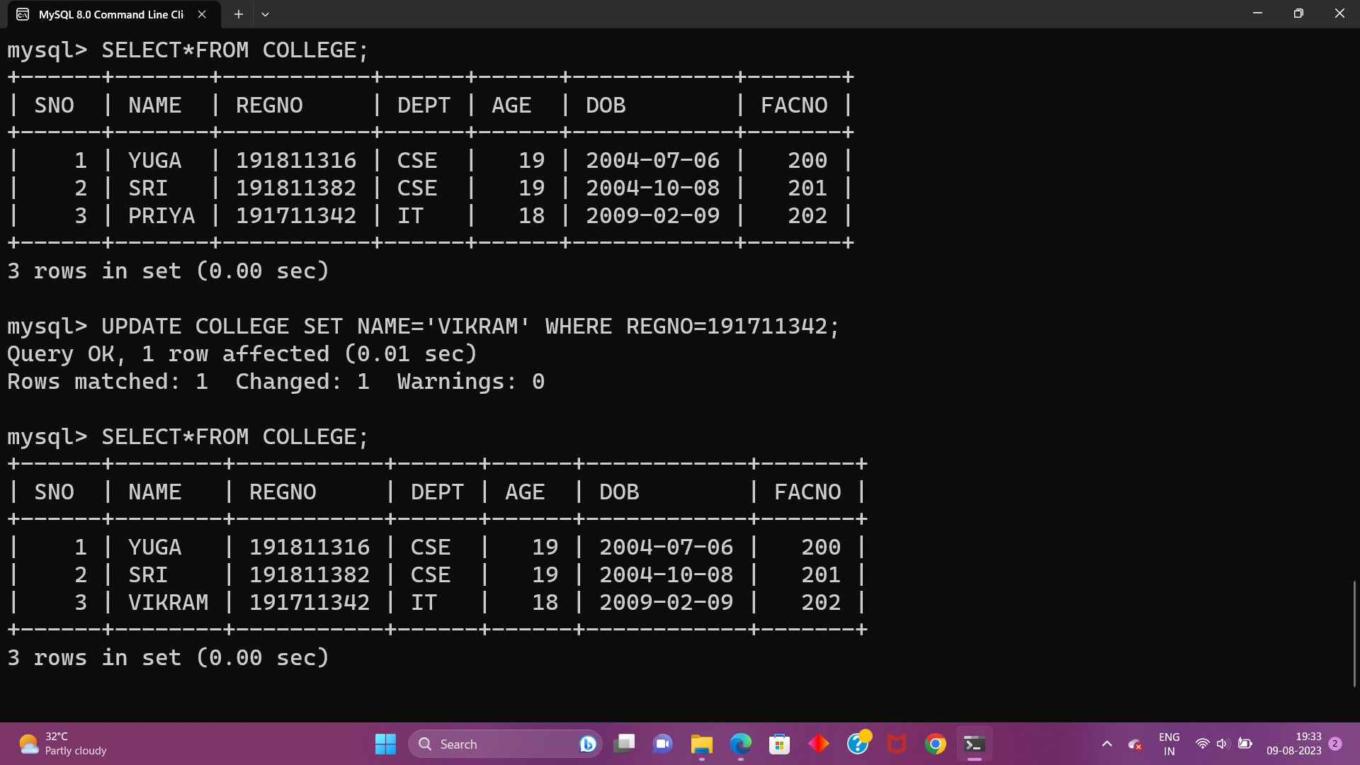

3.Delete the record in the table faculty,who resigned her job

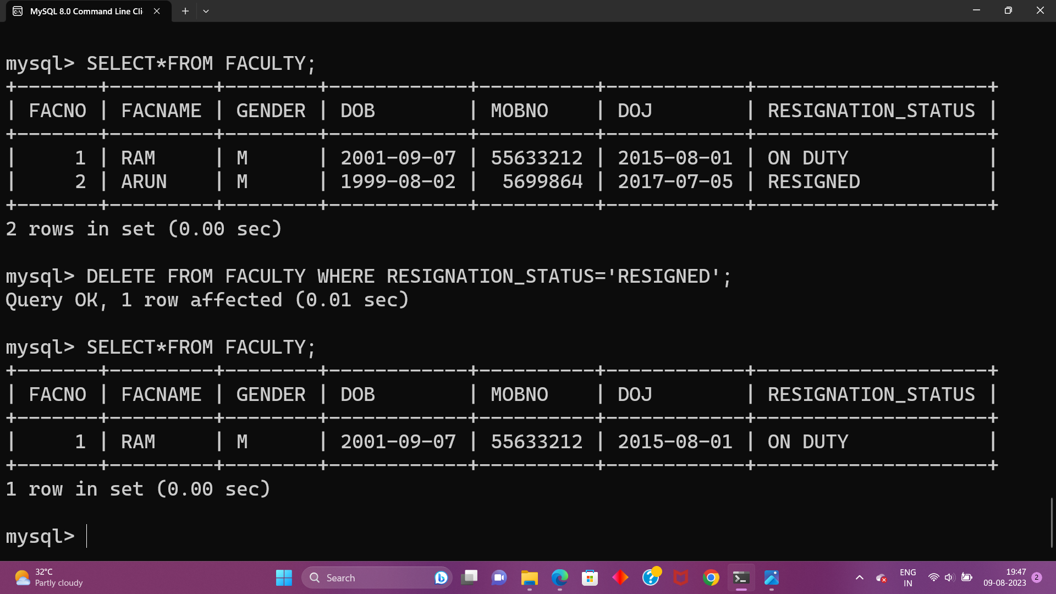

4.Modify the dob for the faculty whose name is ‘ram’ with a value ‘1983-05-01’.

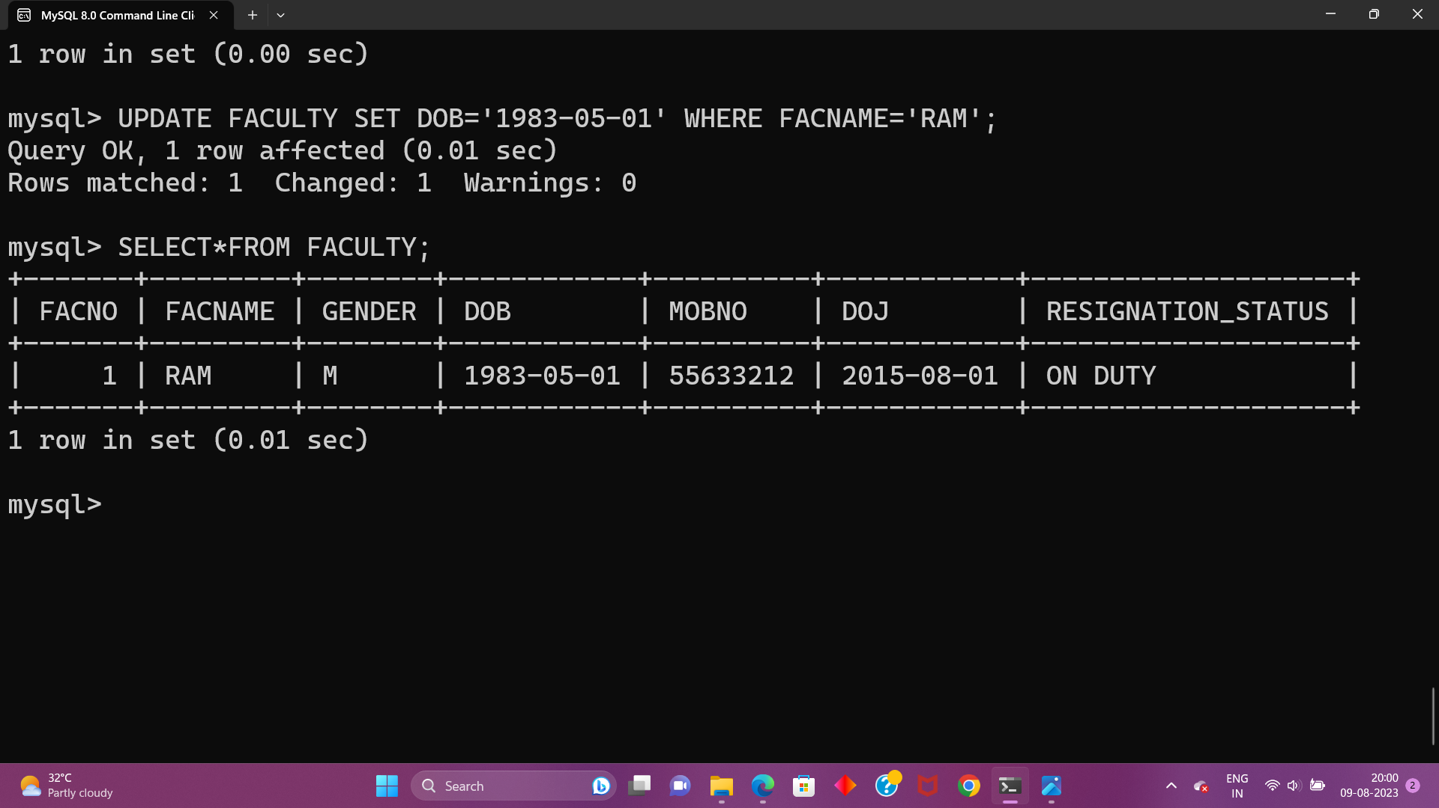

5. Remove all faculty who are having over 65 years.

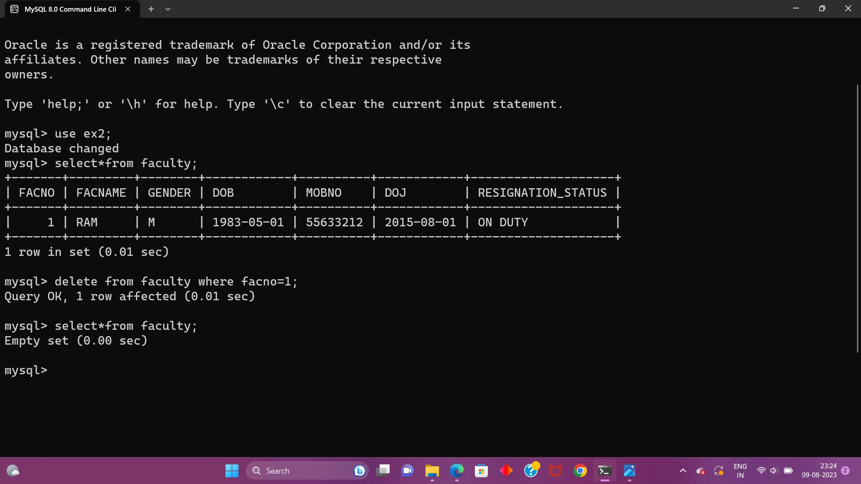

6.View all the records from five tables.

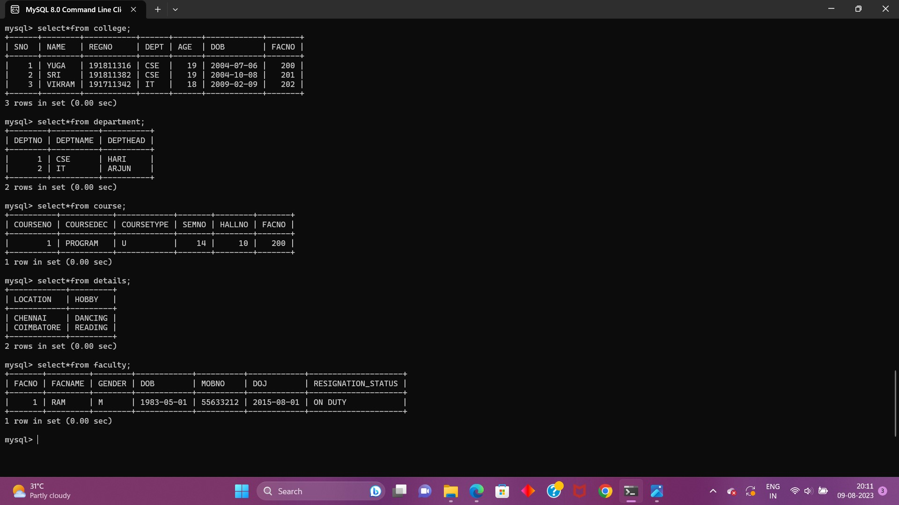

**EX-4**

WHERE:

1. The student counsellor wanted to display the registration number, student name and date of birth for all the students.

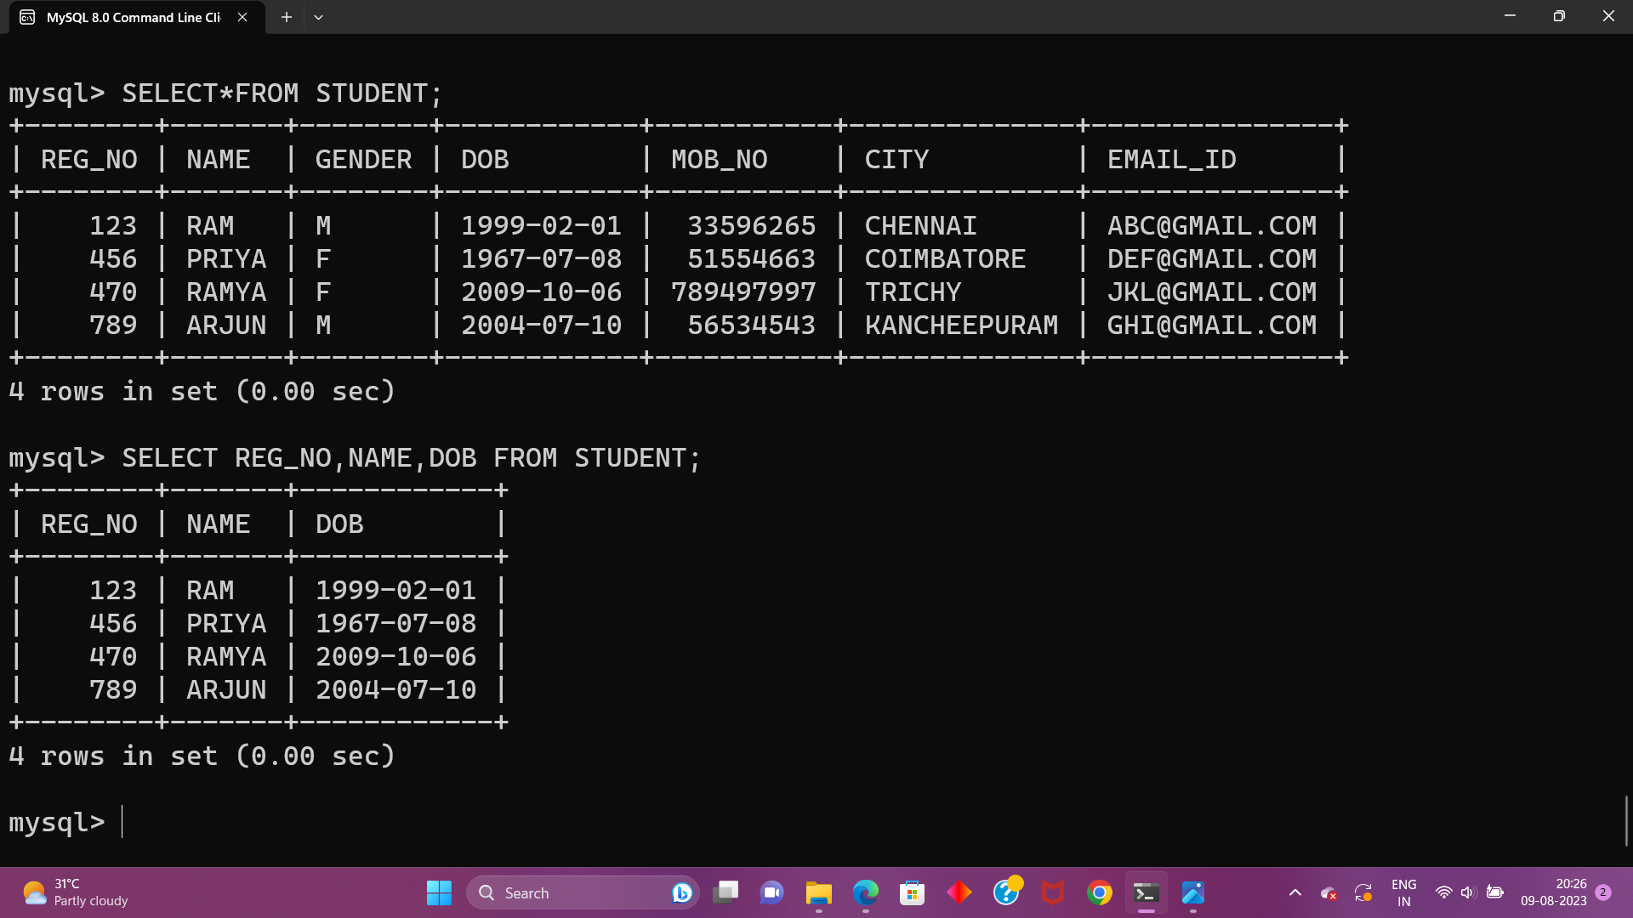

2. The controller of examinations wanted to list all the female students

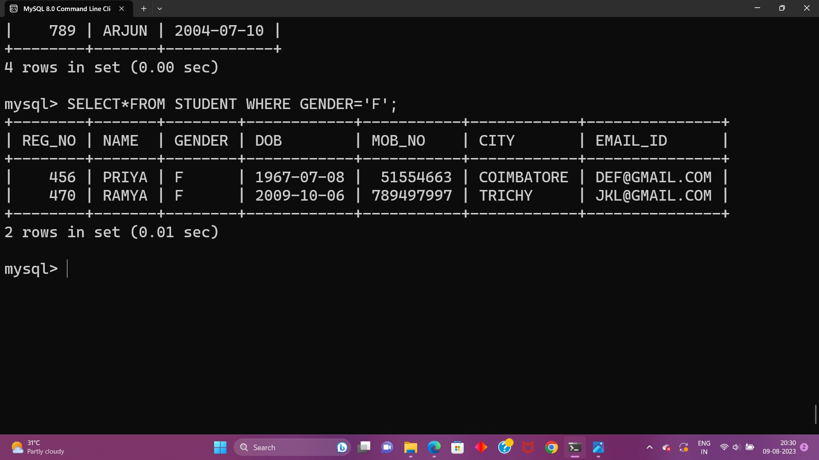

3.Who are the boy students registered for course with the course number “C001“

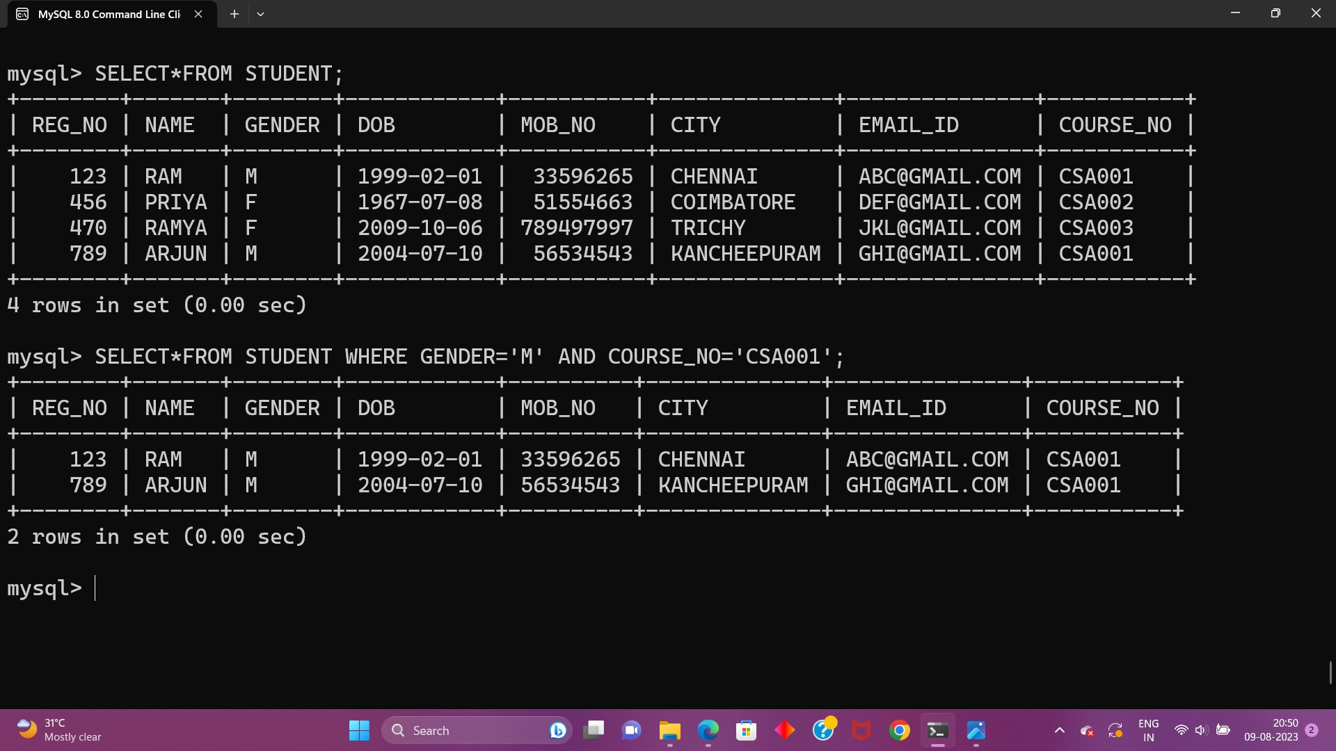

4.Display all faculty details joined before “November 2014”

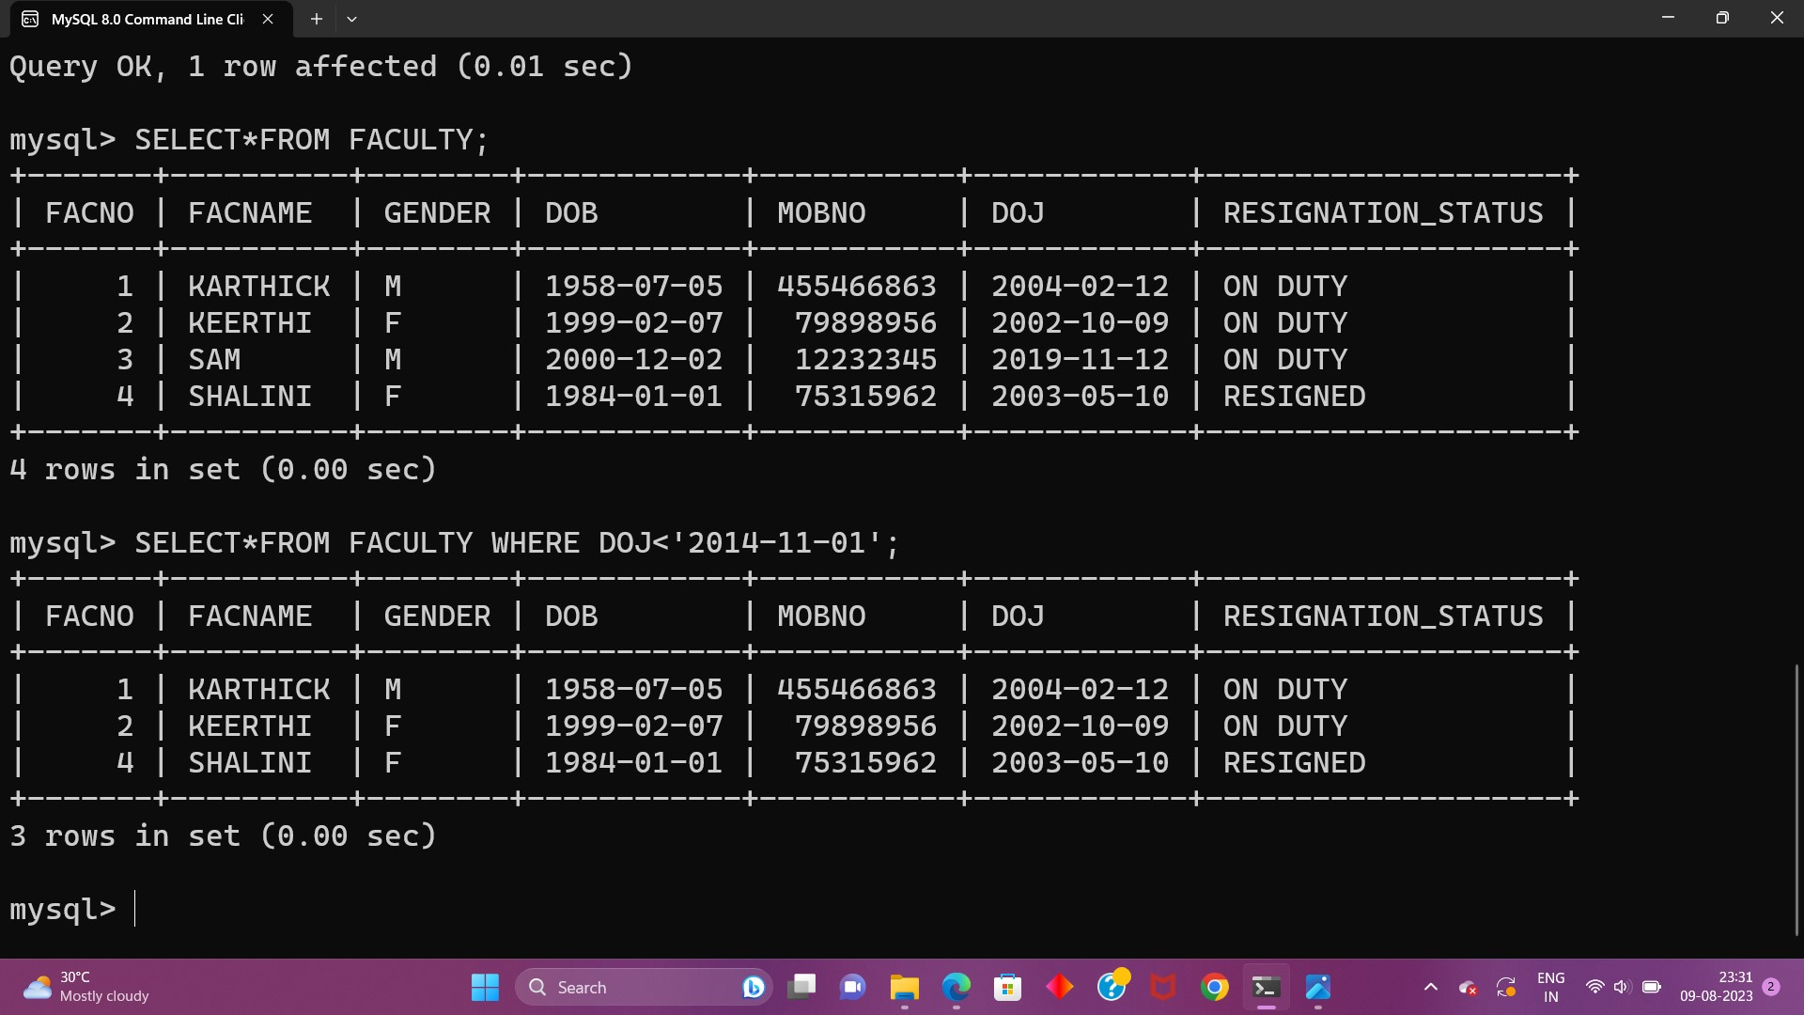

5.Display all the courses not allotted to halls

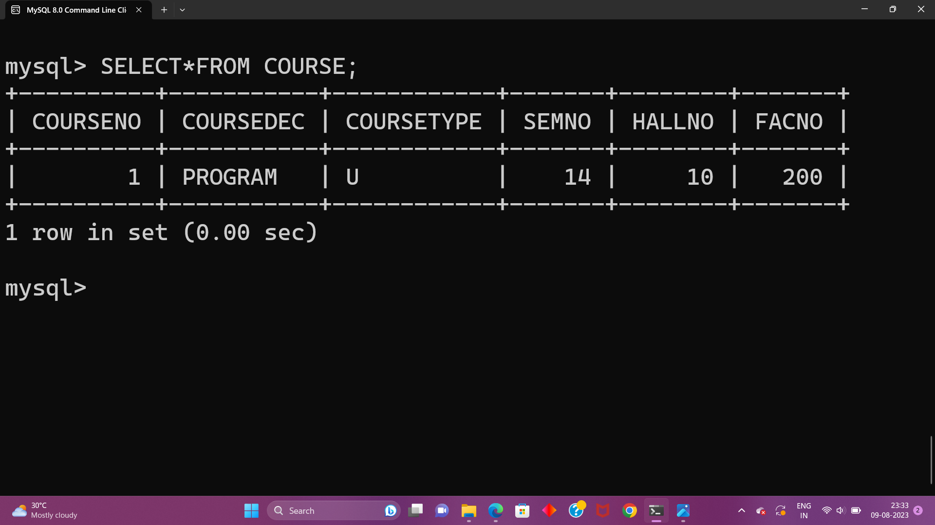

LIKE:

6.List the students whose name ends with the substring “ma”

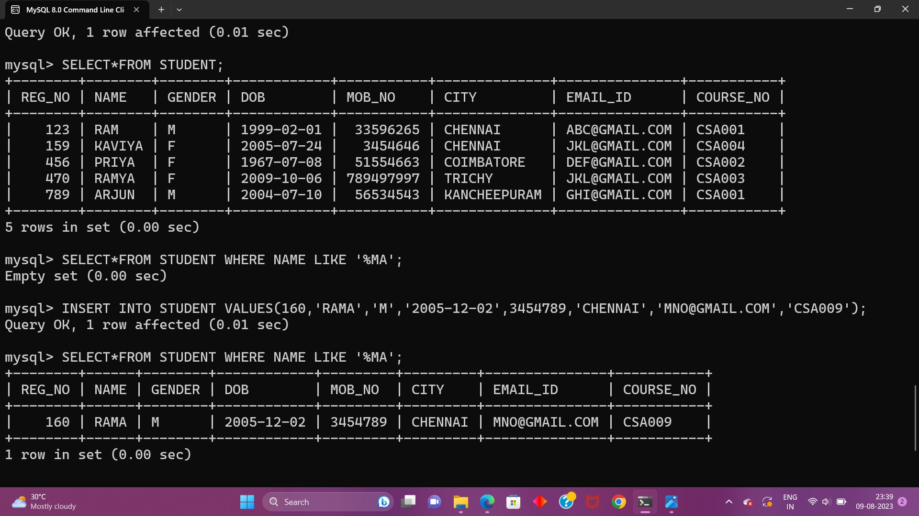

7.Display all students whose name contains the substring “ma”

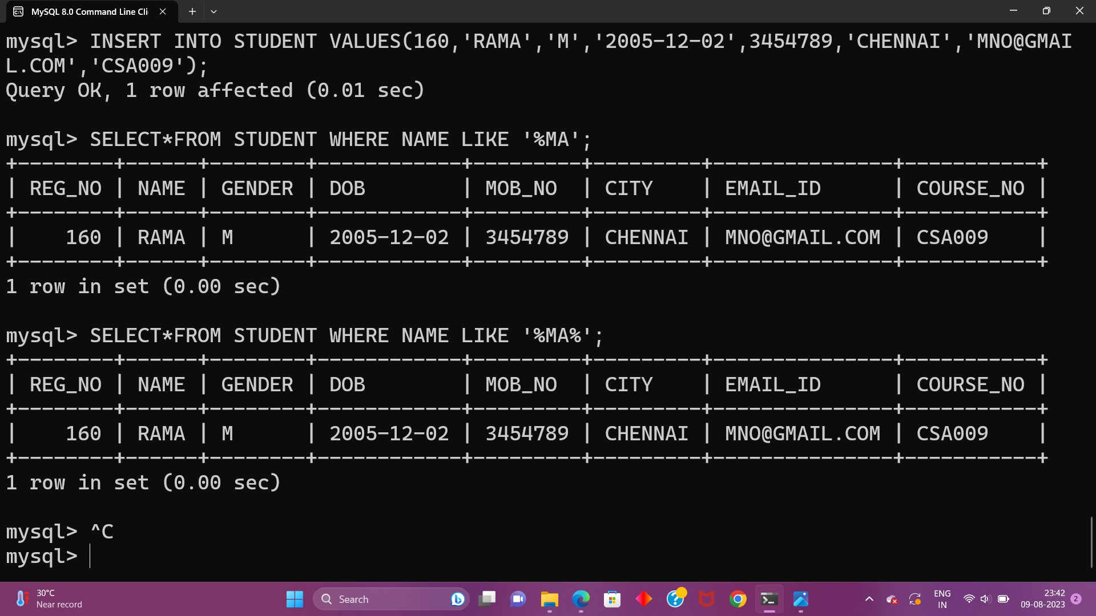

8.Find all the students who are located in cities having “Sal” as substring

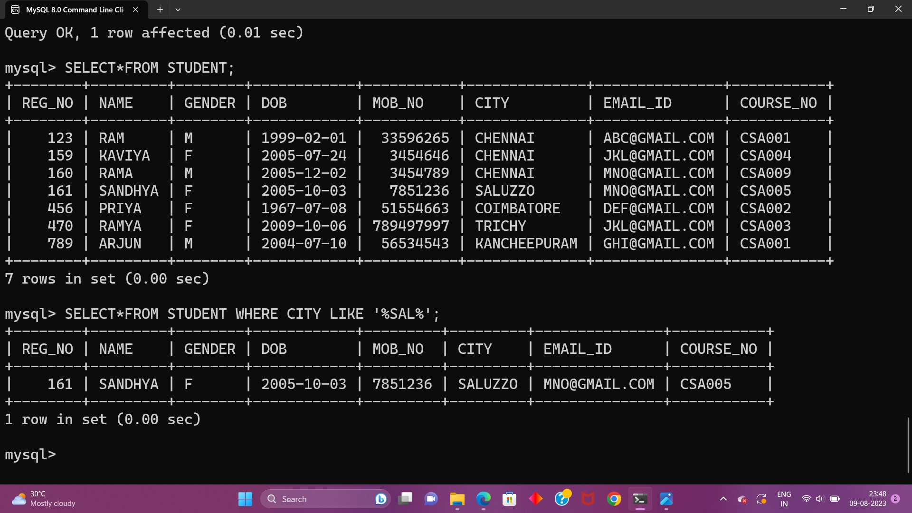

9.Display the students whose names do not contain six letters.

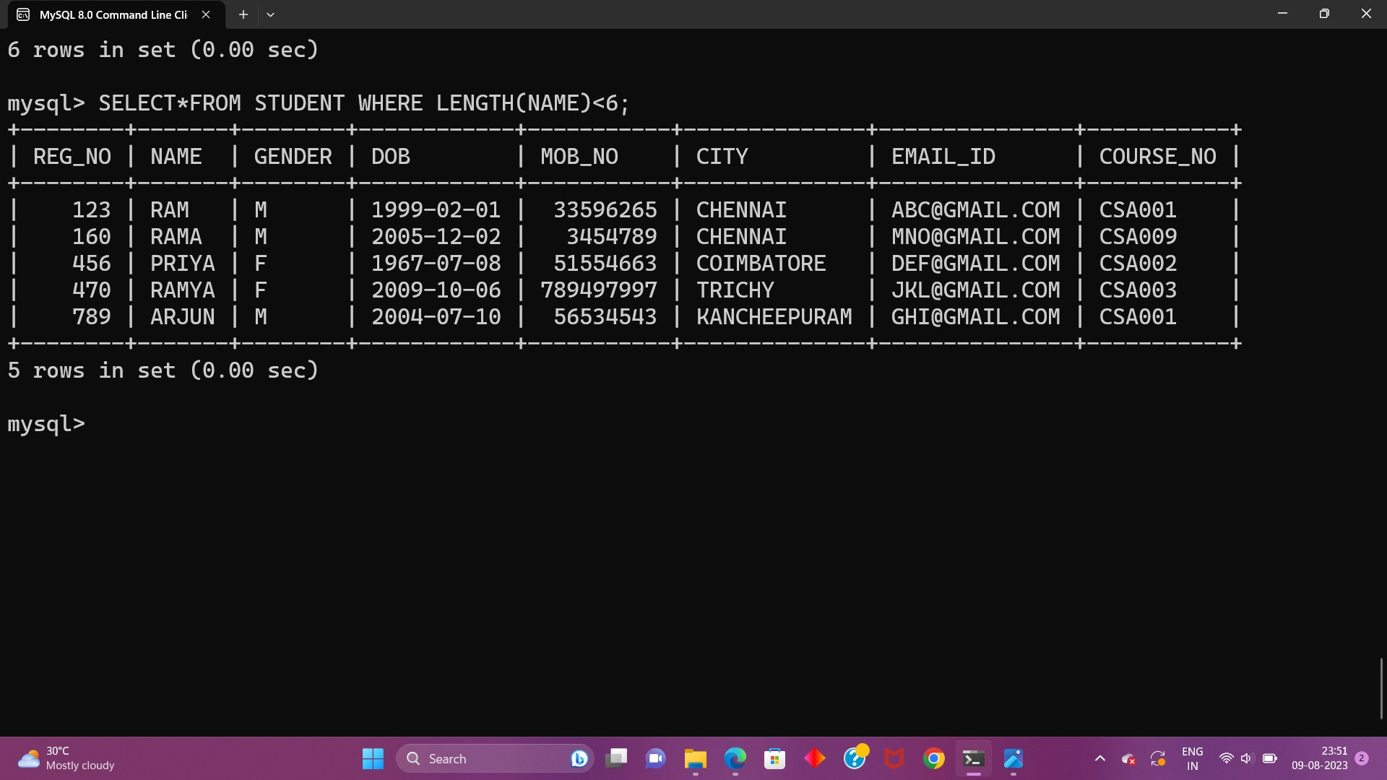

10.Find all the students whose names contains “th”

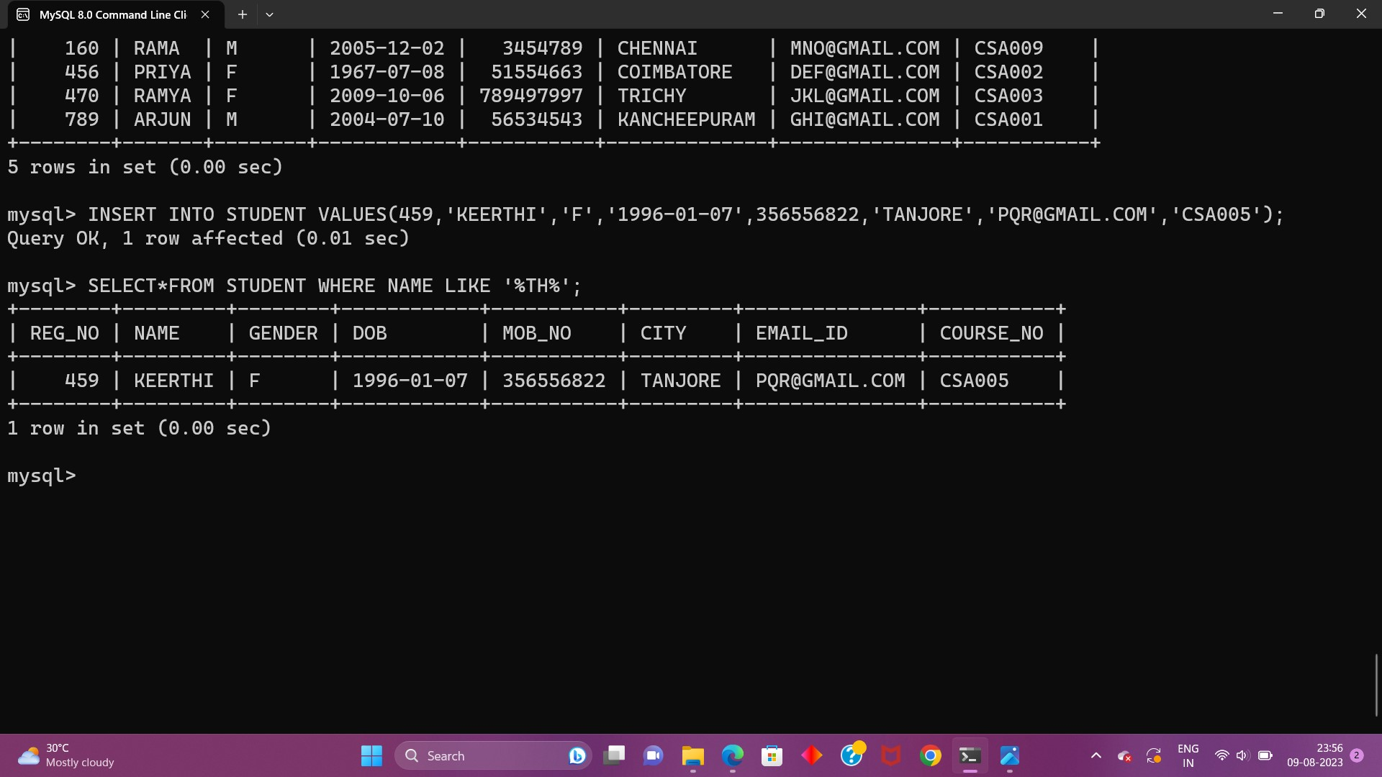

**EX-5**

1.List the type of the courses “Statistics” and “Programming”

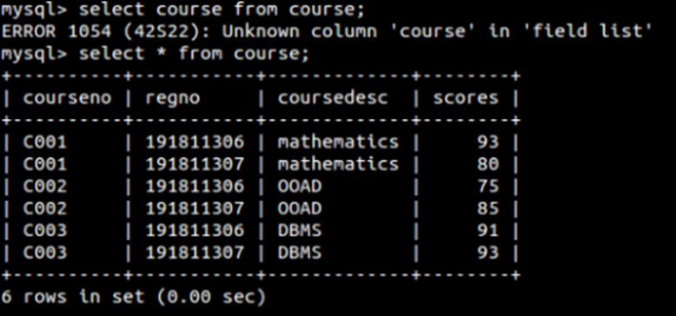

2.List the maximum, minimum mark for “C021”

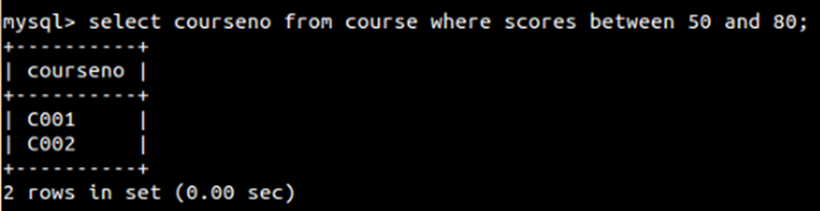

1.Find the average mark of “C002”.

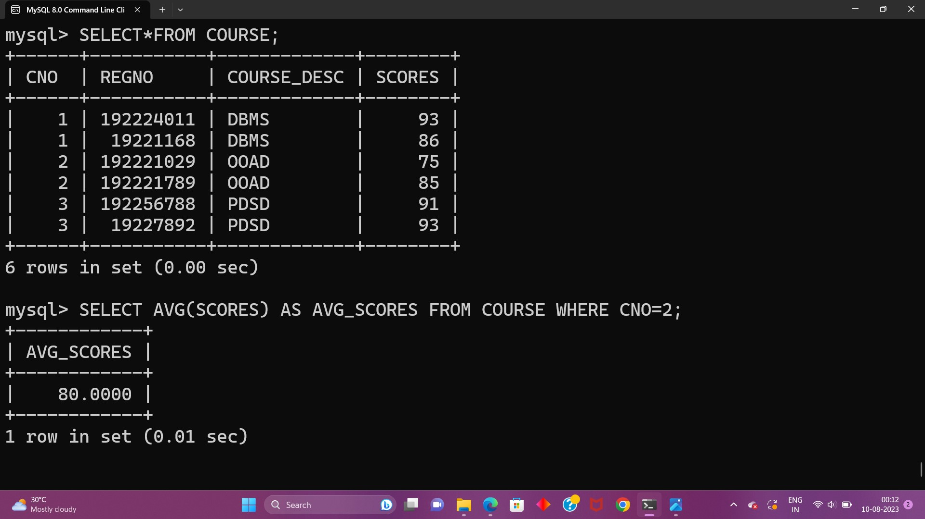

2. List the maximum, minimum mark for “C021”

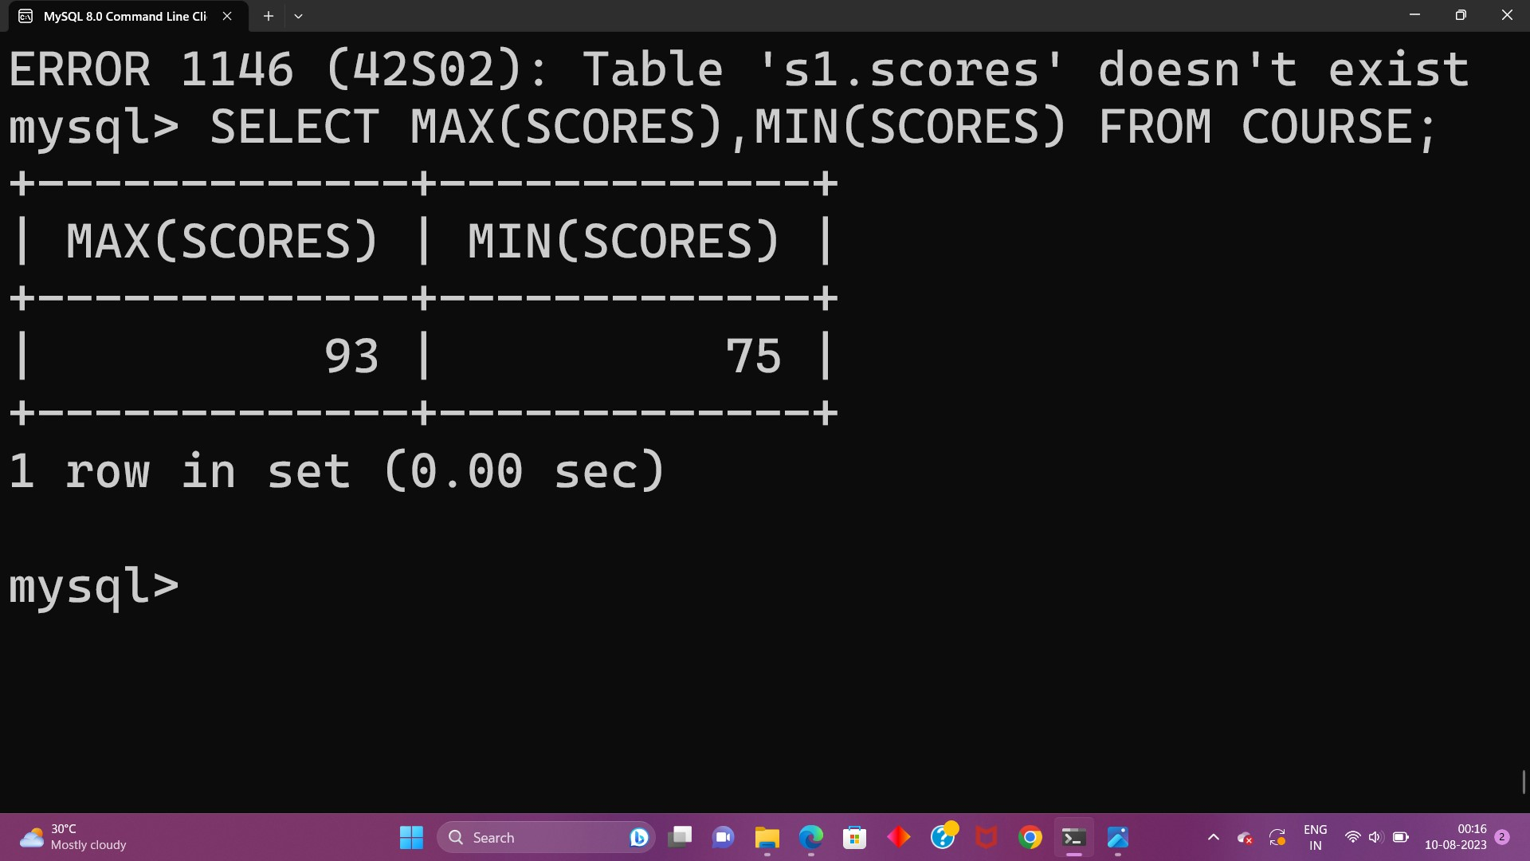

3.List the maximum, minimum, average mark for each subject in 5th semester

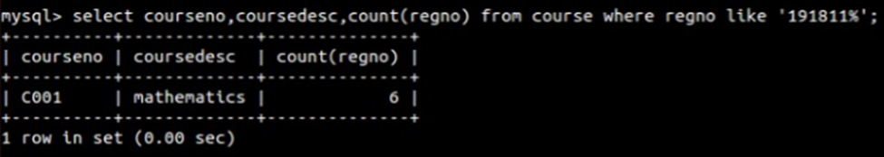

4.List the name of the courses and average mark of each courses.

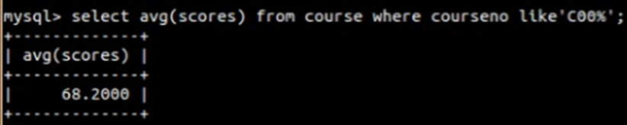

5.Calculate the sum of all the scores

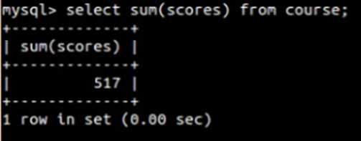

6. How many students are registered for each course? Display the course description and the number of students registered in each course.

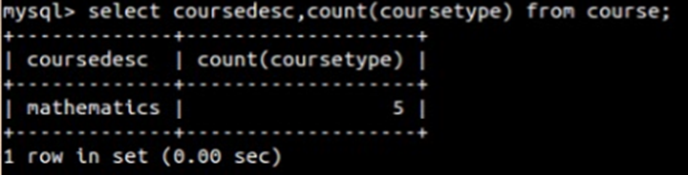

7.How many courses did each student register for? Use Assessment table



**EX-6**

1. How many students are registered for each course? Display the course description and the number of students registered in each course.

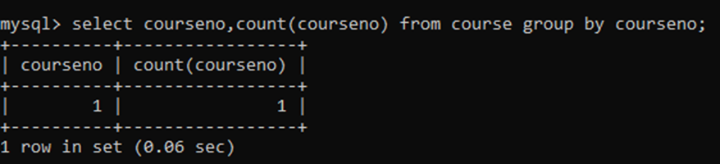

2. How many courses did each student register for? Use Assessment table.

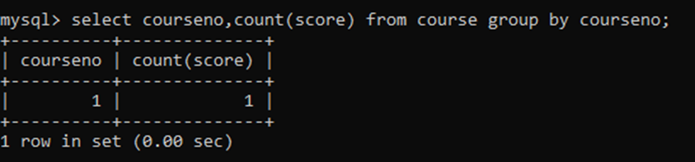

1.Retrieve Name, Gender, MobileNo of all the students in ascending order of RegNo.

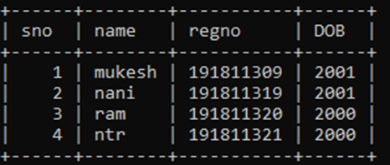

2. List the faculty members in the order of older faculty first.

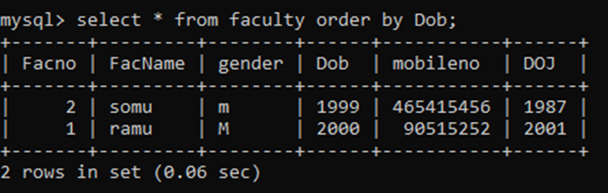

**EX-7**

1. Which of the student’s score is greater than the highest score?

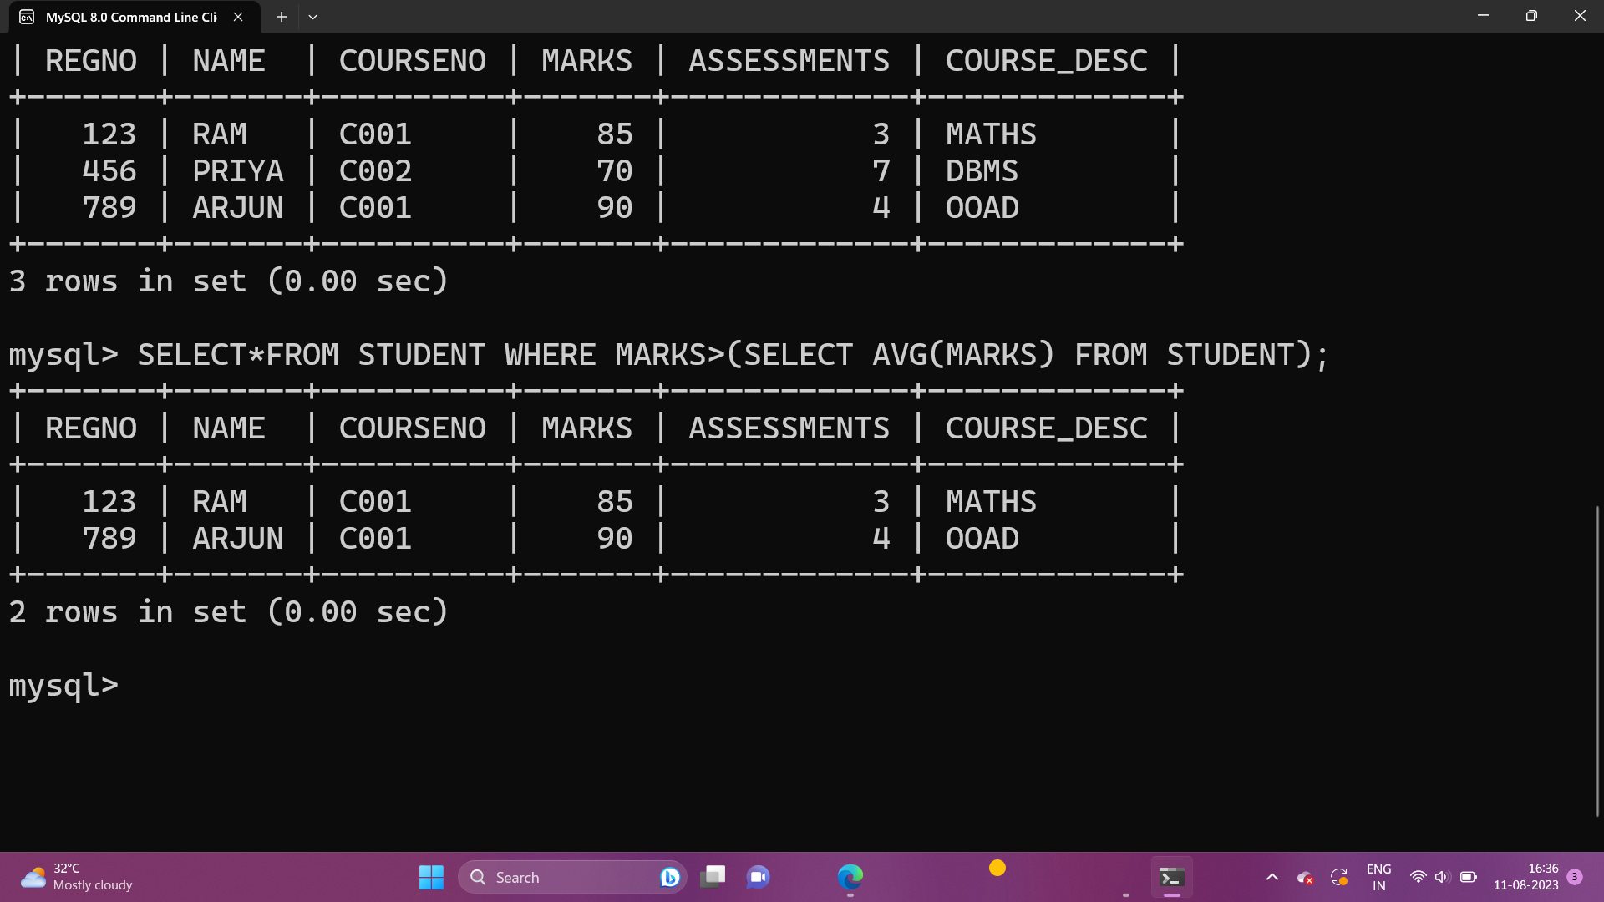

2.Which of the students’ have written more than one assessment test?

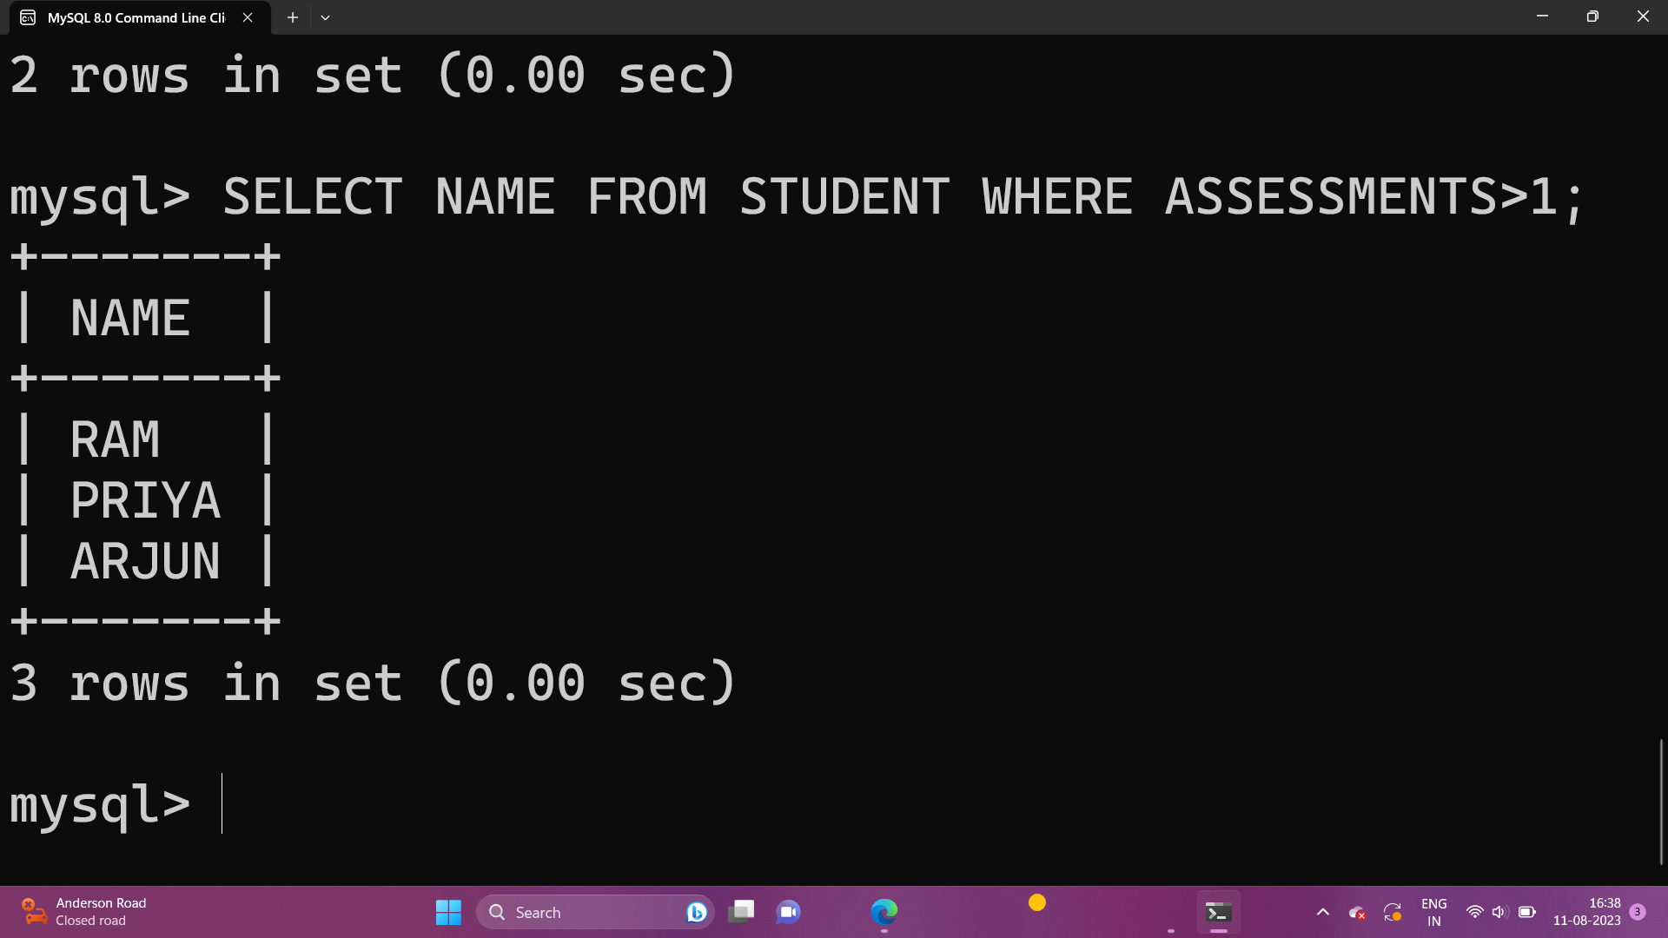

3.Which faculty has joined recently and when?

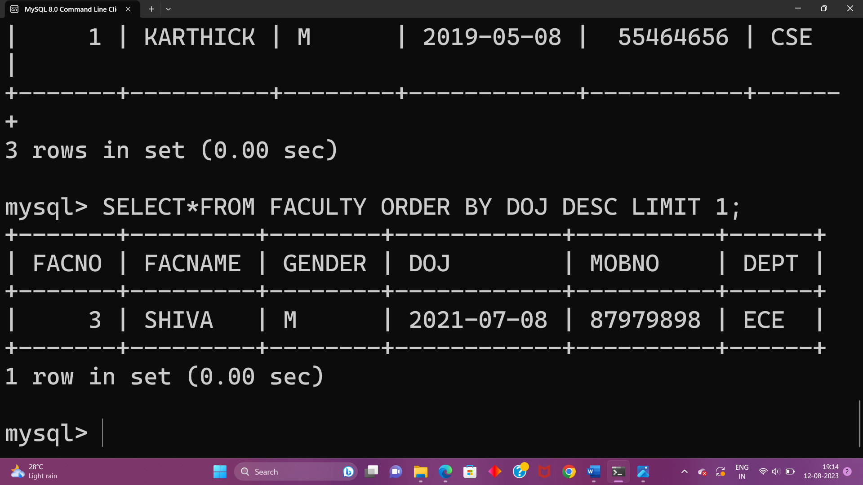

4. List the course and score of assessments that have the value more than the average score each Course

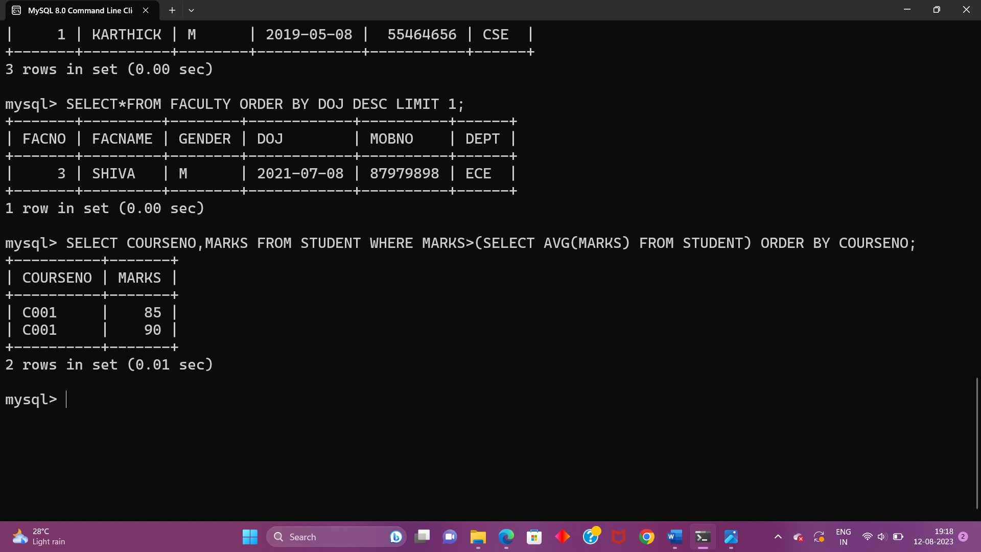

**EX-8**

1. List the departments where the faculty members are working.

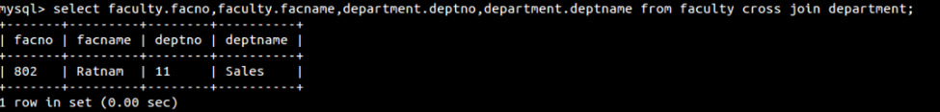

2.Find the student who has no score in any of the courses. List student name and course number.

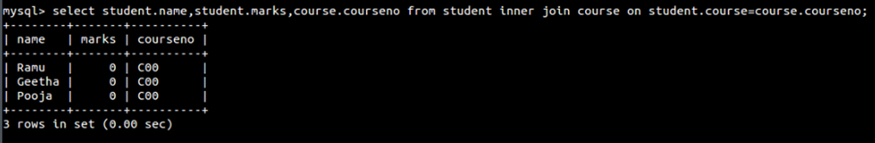

3.The office clerk needs the names of the courses taken by the faculty belonging to ‘ECE department’ whose name is ‘Kamal’

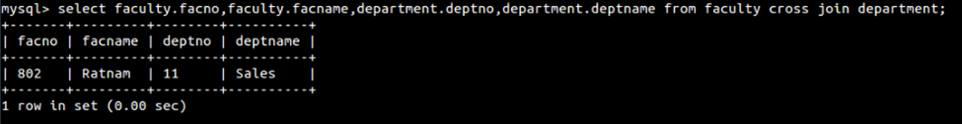

**EX-9**

1.Create a view with name ‘std_view’ using STUDENT table which holds the value of register number, name and DOB of student.

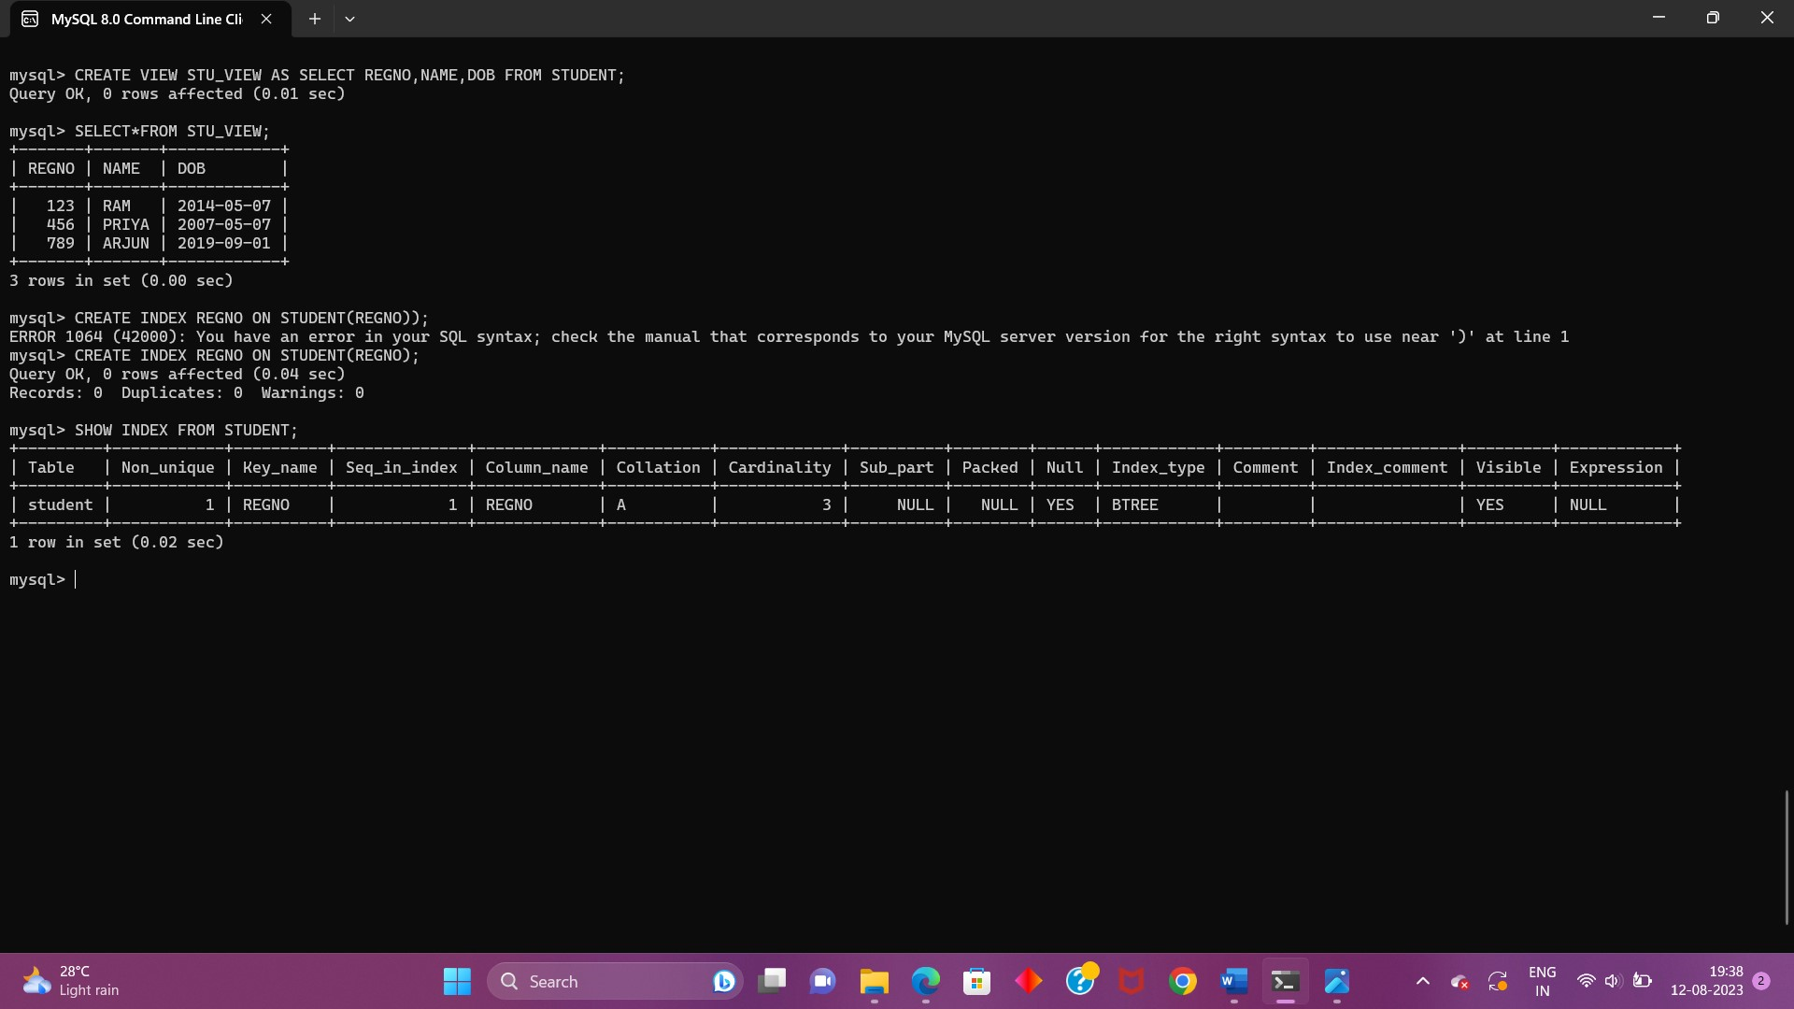

**EX-10**

1.Write a function to build a string repeatedly until the value of the variable becomes s greater than 5. Then, we display the final string using a SELECT statement.

2.Write a function that uses REPEAT statement which would repeat the loopuntil income is greater than or equal to 4000, at which point the REPEAT loop would beterminated

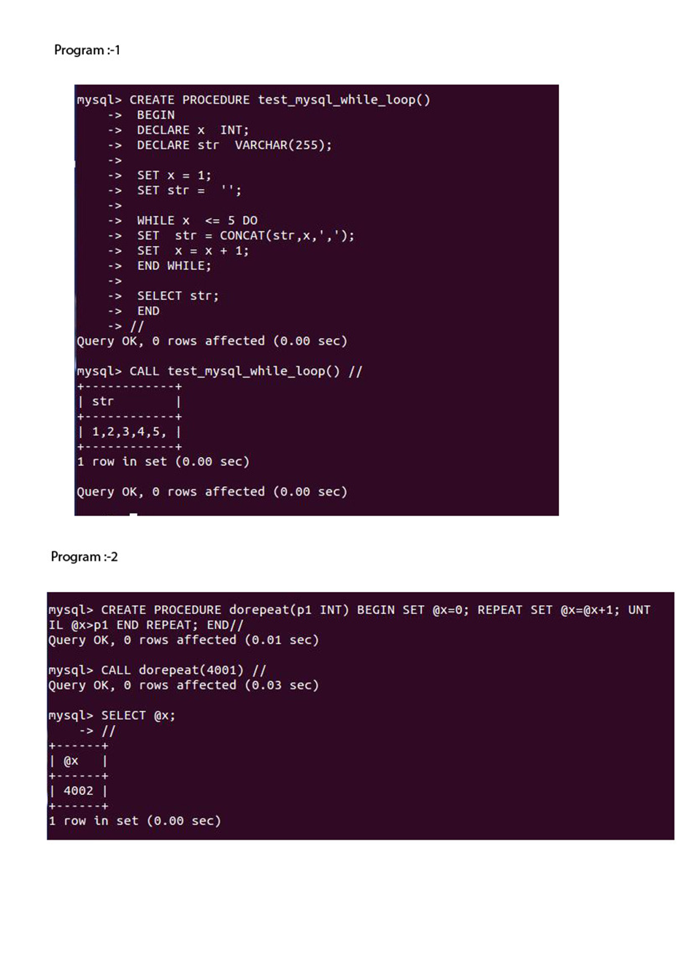

**EX-11**

1.Write a function that uses CASE statement where if monthly_value is equal to or less than 4000, then income_level will be set to 'Low Income'. If monthly_value is equal to or less than 5000, then income_level will be set to 'Avg Income'. Otherwise, income_levelwill be set to 'High Income'.

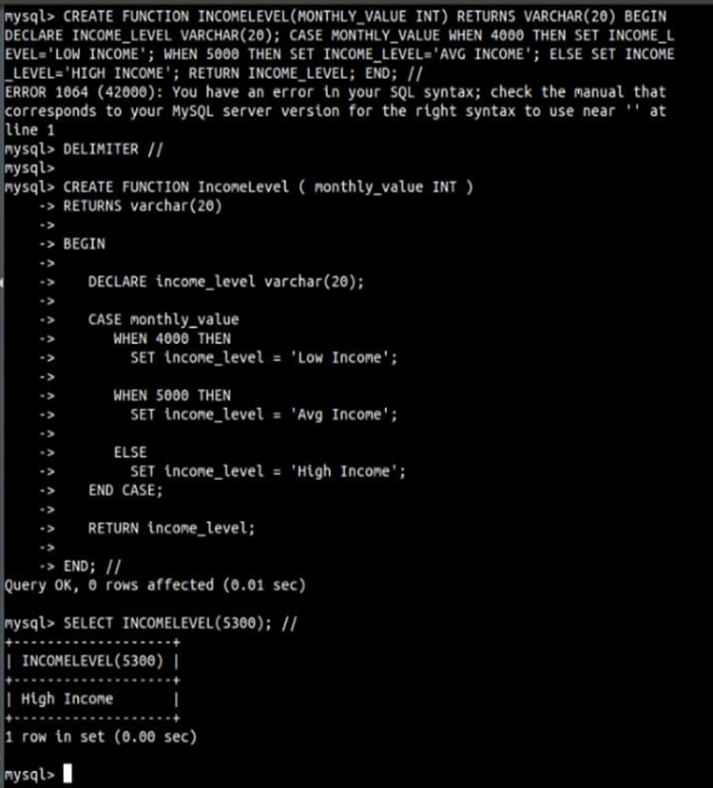

2.Write a function that will use ITERATE statement which would cause the loop to repeat while income is less than 4000. Once income is greater than or equal to 4000, would terminate the LOOP.

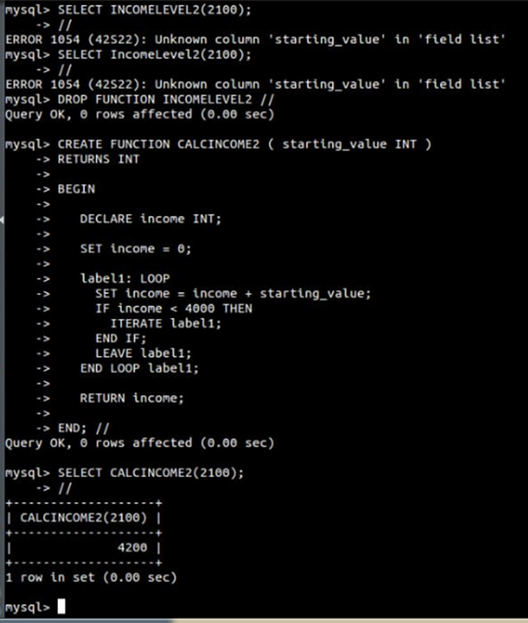

**EX-12**

1.Rollback to that state using the ROLLBACK command whenever required.

Create a following table Class and insert values into it in the order and create savepoints in between them. Try to rollback t the save point and check your output by giving select commands.

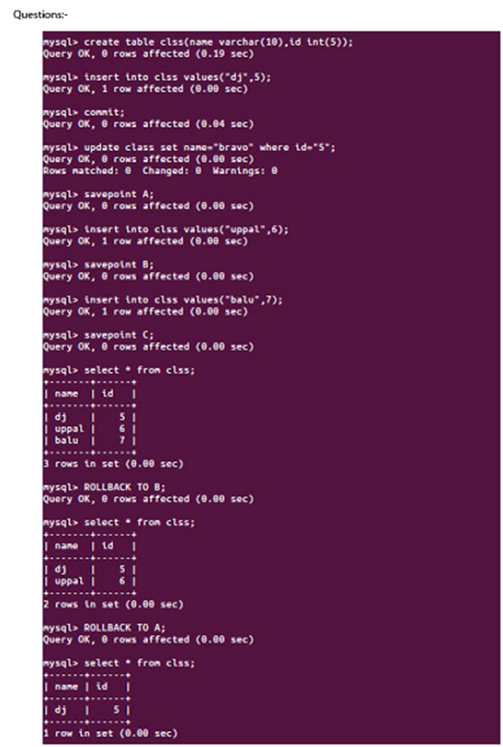

**EX-14**

1.Create a simple procedure to get all the records from the table ‘student_info’ which have the following data:

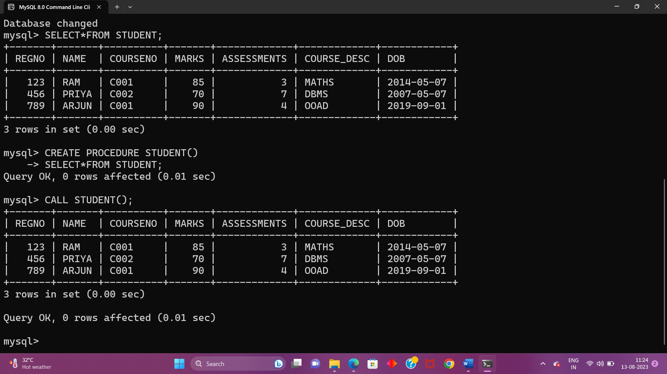

2.Create a stored procedure GetCustomerLevel() that accepts two parameters customer number and customer level.

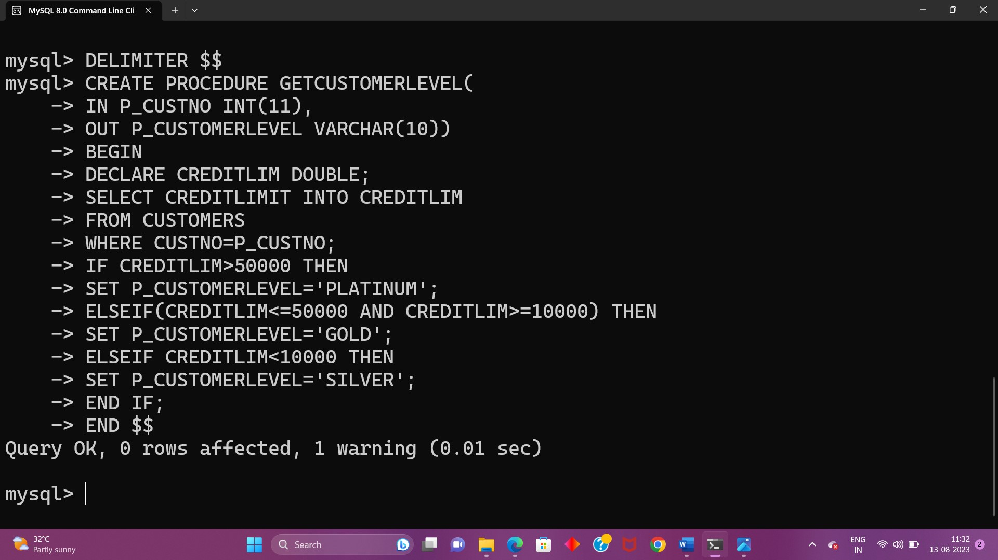

**EX-15**

1.Create a function that returns the level of a customer based on credit limit.(Use the IF statement to determine the credit limit).

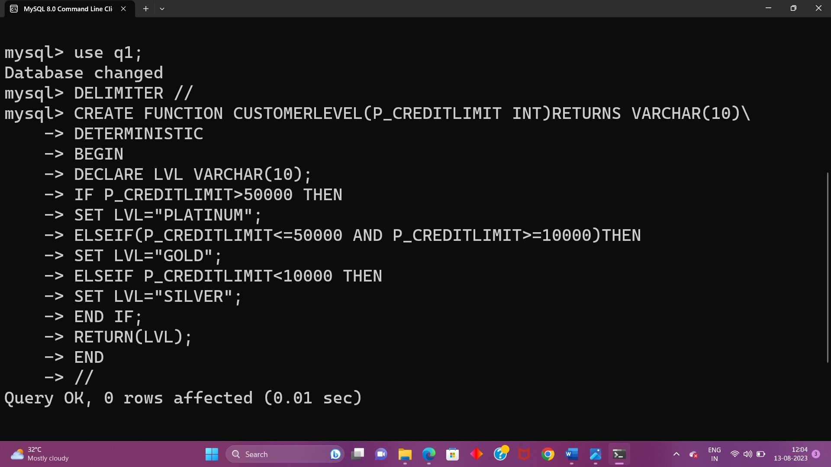

2.Write a recursive MySQL procedure compute the factorial of a number

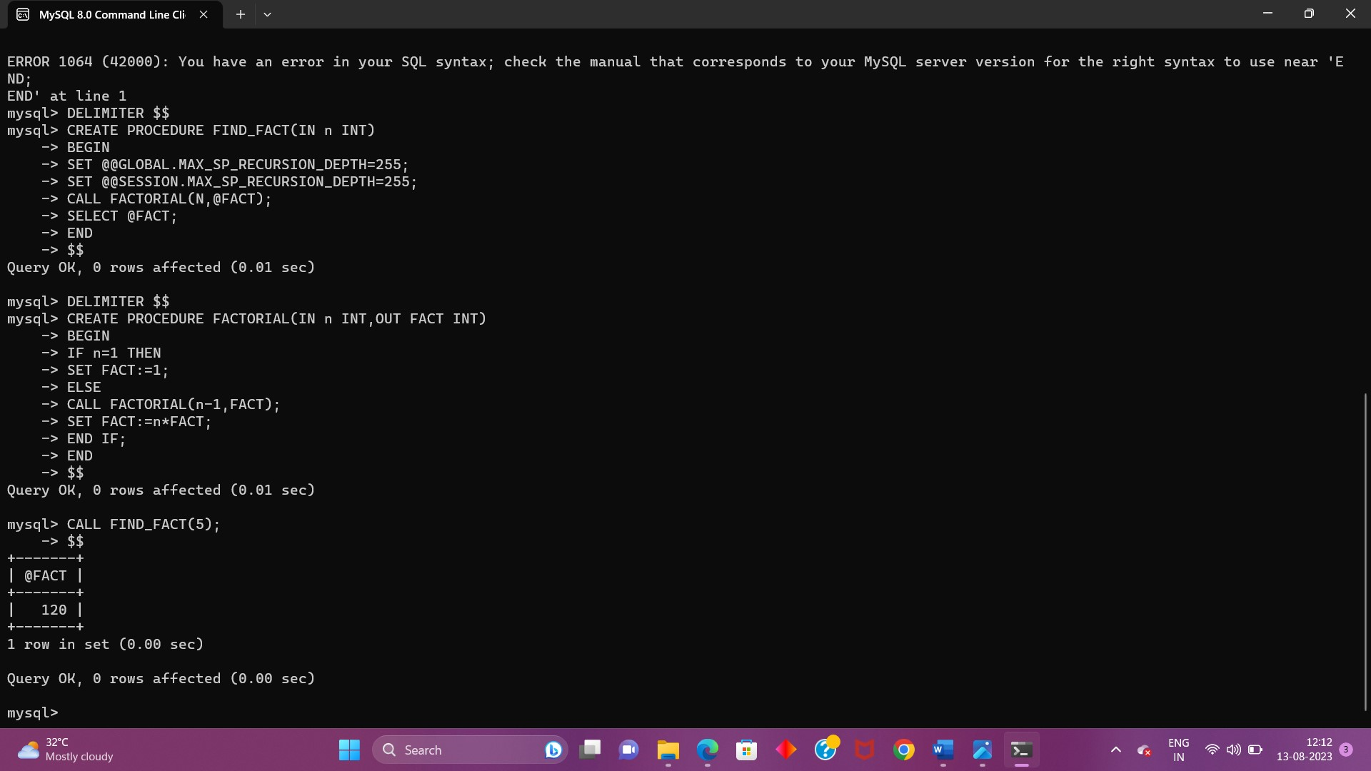

**EX-16**

1.Write a Cursor program using MySQL to retrieve the email-ids(build an email list) of employees from employees table.

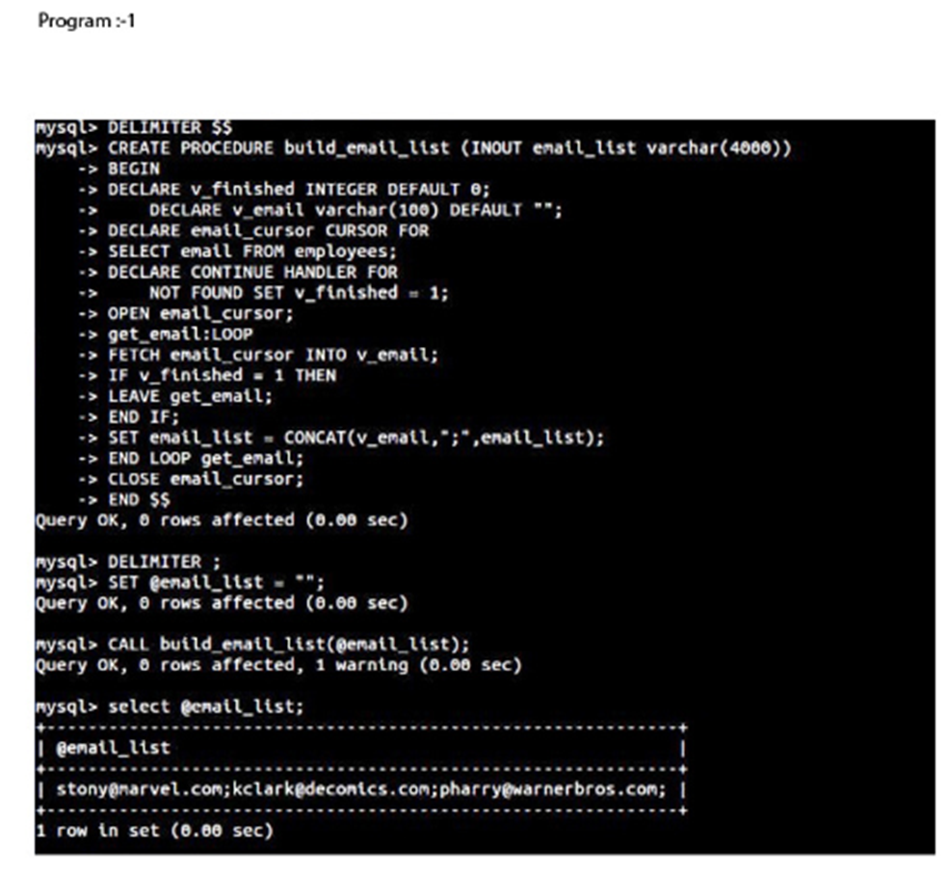

**EX-17**

1.Create a trigger in MySQL to log the changes of the EMPLOYEES table with fields ID, Name and Email. Also create a new table named EMPLOYEES_AUDIT to keep the changes of the employee table. Create a BEFORE UPDATE trigger that is invoked before a change is made to the employees table.

